UC Irvine
Implementation Guidelines and PPS Procedures
New Race and Ethnicity Categories
Effective August 1, 2010
New Collection and Reporting Process:
Effective August 1, 2010 new employees should complete the revised U5605 (R6/10) “Demographic Data Transmittal” on which they are asked to self-identify their ethnicity and race by completing Sections 1A and 1B of the form (See appendix C).
For Section 1A it is necessary to record all checkboxes (multiple selections) as required by IPEDS. For Section 1B it is necessary to record only one checkbox (single selection), for Affirmative Action Program reporting. Checking multiple selections in Section 1B checkboxes invalidates the section.
New employees are asked to:
- Section 1A - Specify if they are of Hispanic, Latino, or Other Spanish origin
  - This is a single Yes/No response
  - Select one or more races from the following list of five choices
    - American Indian or Alaska Native
    - Asian
    - Black/African American
    - Native Hawaiian or Other Pacific Islander
    - White
- Section 1B - Select one primary race/ethnicity category with which they most closely identify from the following list.
    - American Indian or Alaska Native
    - Asian
      - Chinese/Chinese American
      - Filipino/Pilipino
      - Japanese/Japanese American
      - Native Hawaiian or Other Pacific Islander
      - Pakistani/East Indian
      - Other Asian
    - Black/African American (not of Hispanic origin)
    - Hispanic
      - Mexican/Mexican American/Chicano
      - Latin American/Latino
      - Other Spanish/Spanish American
    - White (not of Hispanic origin)
All the elements of Form U5605 are captured on PPS screen EPD1. The elements are arranged so that when entering data a user can tab from field to field in the same sequence that the elements appear on the revised form.
Six new fields have been added to record the responses from section 1A as follows:
- Hispanic Indicator
- American Indian or Alaska Native Indicator
- Asian Indicator
- Black/African American Indicator
- Native Hawaiian or Other Pacific Islander Indicator
- White Indicator
All fields are one character alphanumeric. ‘Y’ for yes, ‘N’ for No, or blank (default).
The existing Ethnic field carries forward as the receptacle for the response entered in Section 1B of the form. This field has been relabeled as the Primary Ethnicity/Race field which has the same choices as the old form U5605 plus a new code “Z” for “Native Hawaiian or Other Pacific Islander”.

Code List
F - White (not of Hispanic origin)
A - Black/African-American (not of Hispanic origin)
2 - Chinese/Chinese-American
B - Japanese/Japanese-American
L - Filipino/Pilipino
R - Pakistani/East Indian
X - Other Asian
C - American Indian or Alaska Native
E - Mexican/Mexican-American/Chicano
5 - Latin American/Latino
W - Other Spanish/Spanish-American
Z - Native Hawaiian or Other Pacific Islander (new code)
U - Unknown

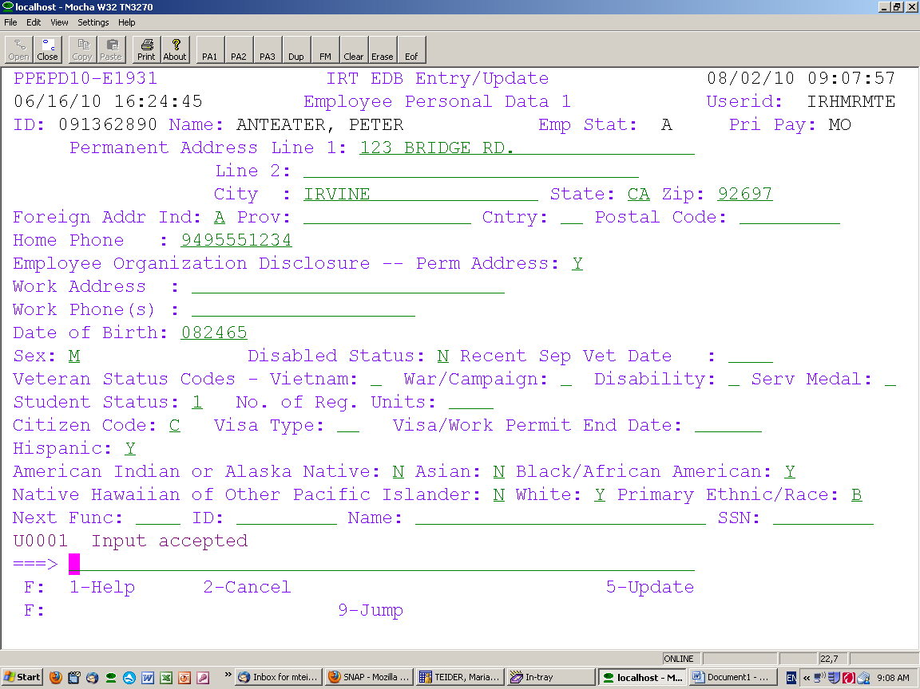
New Elements

Fields record responses from Section 1A of Form U5605
EDB 0112

Field records responses from Section 1B of Form U5605

New Data Entry Guidelines and Scenarios:
Data entry in PPS does not restrict the combination of responses that can be recorded even if it suggests that instructions on the Demographic Data Transmittal Form were not followed or the combination is self-contradictory.
Sample selections from Form U5605
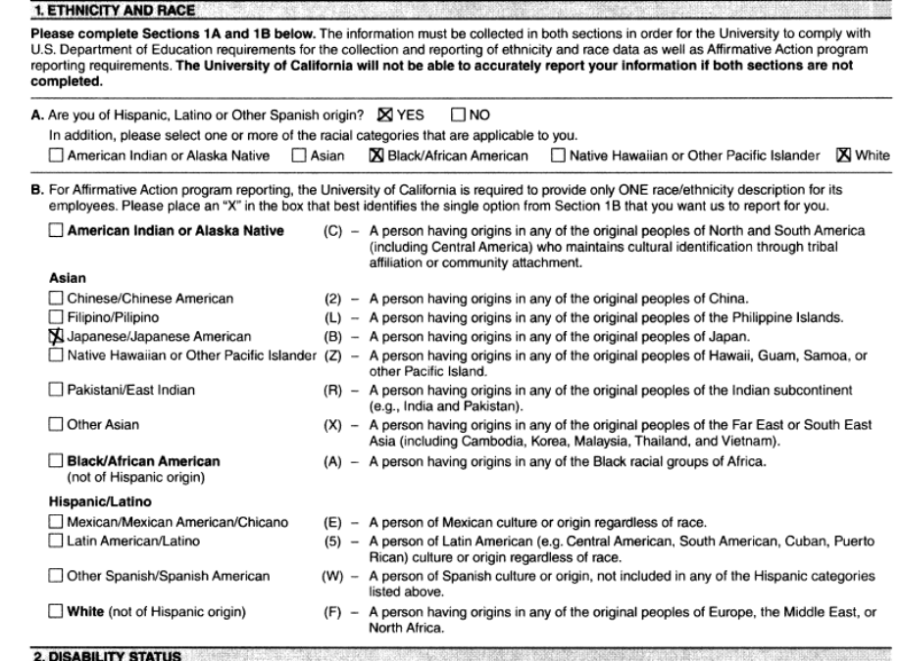

Corresponding Sample PPS EPD1 Screen
Data entry to record Section 1A responses based on sample form
Data entry to record Section 1B responses based on sample form

When more than one race has been marked in Section 1A of the form and the new employee is not of Hispanic/Latino or Other Spanish origin then all choices marked on the form should be recorded in PPS. The multiple entries are reported to IPEDS as “Two or more races”.
Sample form U5605 selections
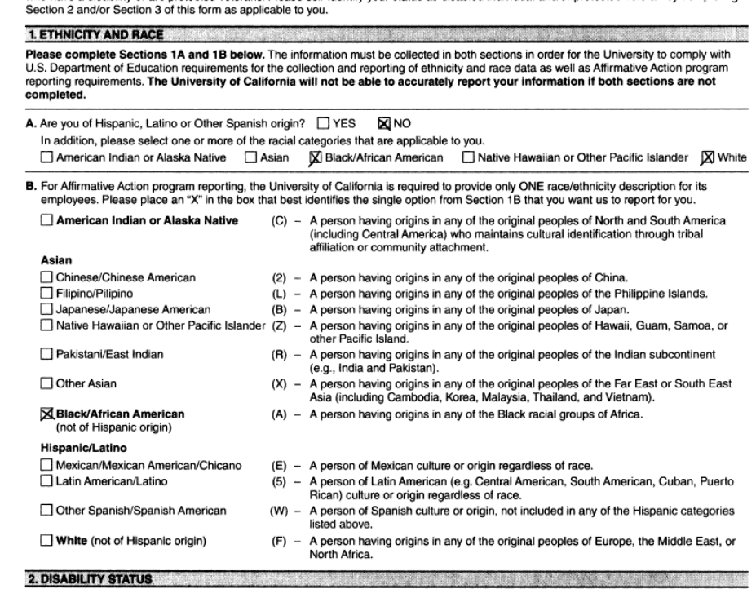

Corresponding sample PPS EPD1 screen

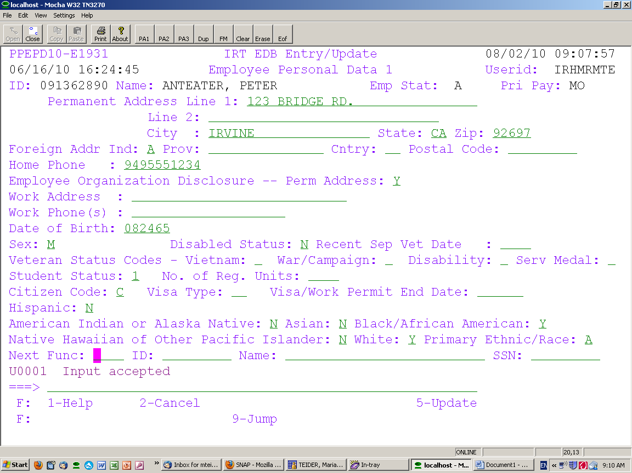
Data entry to record Section 1A responses based on sample form

Data entry to record Section 1B responses based on sample form

When a single response has been marked in Section 1A of the form(such as Hispanics-Y) and Section 1B is left blank, the system will automatically derive code “O” for Hispanic (derived from Section 1A of U5605) to auto-populate the Primary Ethnic/Race field.
Additional Derived Codes

O – Hispanic (derived from U5605 Section 1A)
P – Black/African American (derived from U5605 Section 1A)
Q – American Indian or Alaska Native (derived from U5605 Section 1A)
S – Asian (derived from U5605 Section 1A)
T – Native Hawaiian or Other Pacific Islander (derived from U5605 Section 1A)
V – White (derived from U5605 Section 1A)
Sample form U5605 selections
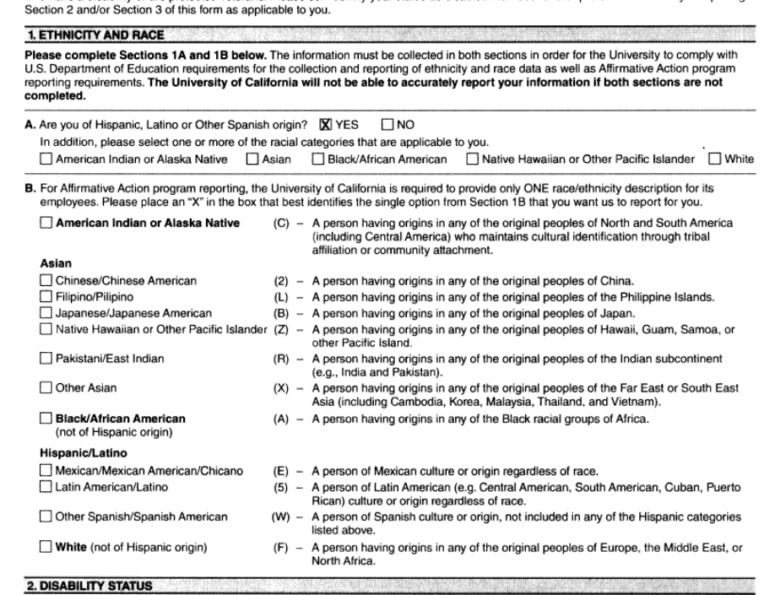
Corresponding sample PPS EPD1 screen
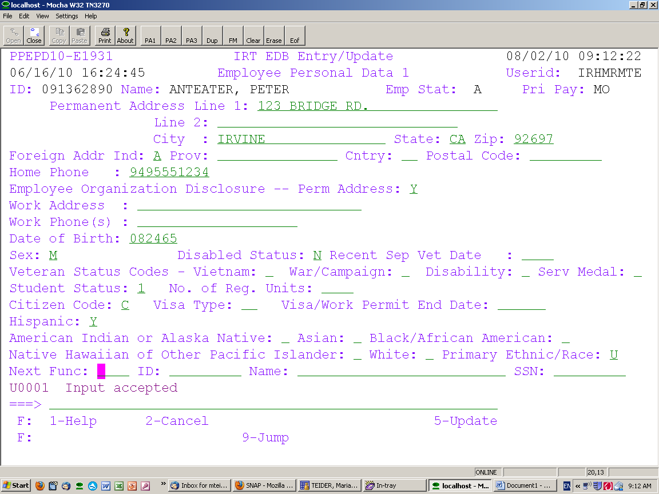
Data entry to record Section 1A responses based on sample form
Derived code auto-populates Primary Ethnicity/Race field when Section 1B is left blank

When a single response has been marked in Section 1A of the form but multiple responses were marked for Section 1B, the multiple selections marked in Section 1B will not be validated. The applicable ‘Y’ response will be entered for the appropriate field to capture the category marked for Section 1A and code ‘U’ should be entered in the Primary Ethnic/Race field.
Sample form U5605 selections
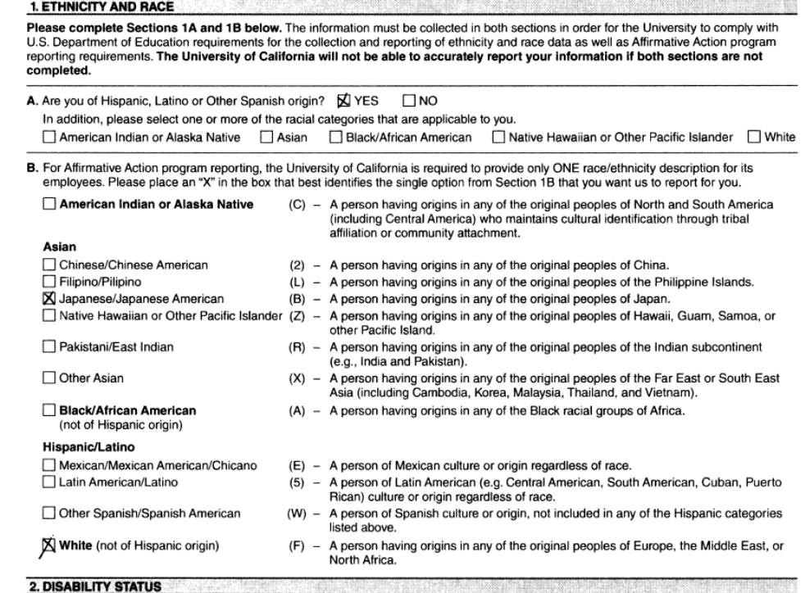
Corresponding sample PPS EPD1 screen
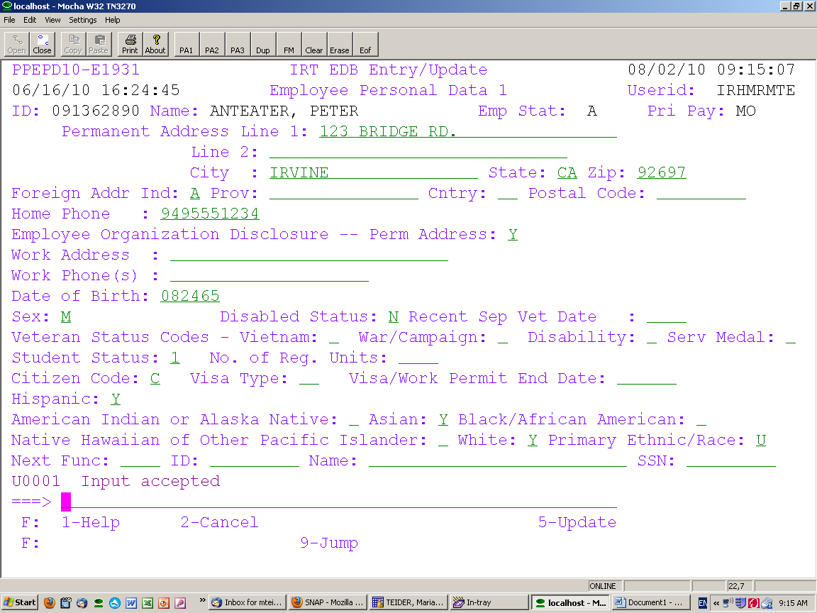
Data entry to record Section 1A responses based on sample form

Data entry to record Section 1B responses based on sample form

General Information 1 (IGEN)
The six new elements were added to IGEN. This screen now combines Sex and Ethnic ID onto one row, then Hispanic indicator on one row, and the racial indicators on the next row. The abbreviation AI/A/AA/NH/W stands for American Indian, Asian, Black/African American, Native Hawaiian, and White.
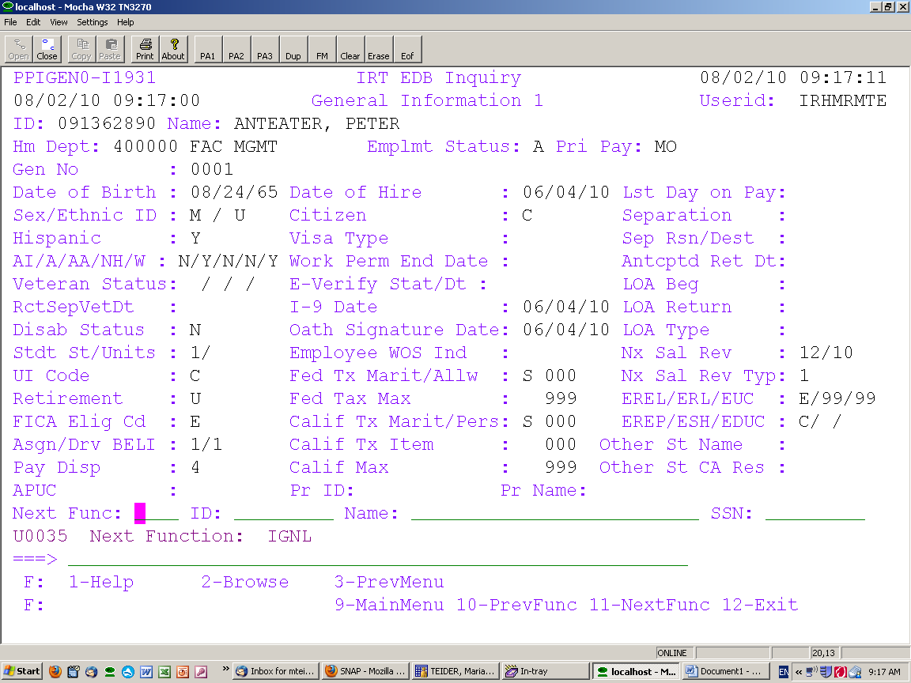

If you have any questions, please contact Maria Teider at 949.824.8031 or mteider@uci.edu.

