How To: Copy an Existing Account to a New Account
Summary: The Account Lookup screen includes a function which enables users to copy existing accounts to create and submit new accounts.
Replacement: The internal Accounting paper forms for establishing new fund/revenue accounts and expenditure accounts will be replaced by the Copy function in the search results in the KFS Account Lookup screen.
Steps | What you need to do | How to do it
1 | Login to KFS | Please make sure you have logged into SNAP using your UCInetID and have the required access to the link below.
2 | Select the Account | Click on the Account link
3 | Search Accounts | Once in the Account Lookup screen, users can search for a specific Account. The Account Lookup offers users a wide variety of criteria to search for a specific Account. Enter the desired information and click search.  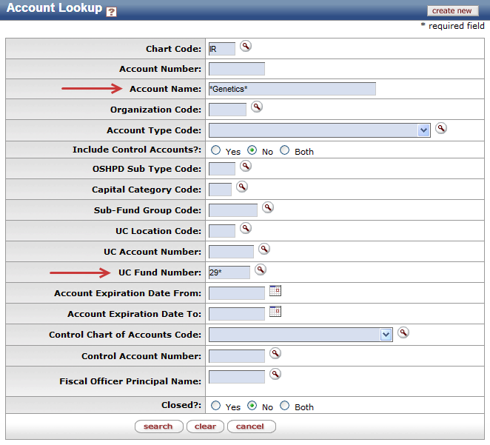  Note: Users can search with partial information by placing an asterisk (*) before and/or after the portion of the search criteria known.
4 | 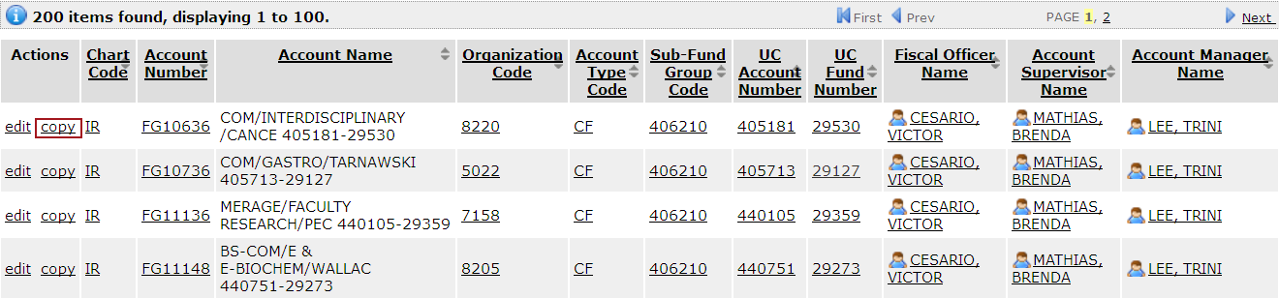  Complete eDoc | When the search results are displayed, users can create a new Account by selecting the copy link for the selected Account. KFS will automatically copy information from the existing Account to a new Account eDoc. Users can then edit the auto-populated information before submitting the eDoc.
5 | Save and Submit eDoc | Once data entry is complete, save and submit Account eDoc.

