How To: Copy an Existing Sub-Account to a New Sub-Account
Summary: The Sub-Account Lookup screen includes a function which enables users to copy existing sub-accounts to create and submit new sub-accounts.
Replacement: Sub-Accounts have no equivalent in the legacy FS system; however, they are an excellent transactional tracking tool for Accounts.
Steps | What you need to do | How to do it
1 | Login to KFS | Note: This How To is designed assuming that you have already logged into SNAP and have the required access to the below link
2 | Select the Sub-Account | Click on the Sub-Account link
3 | Search Sub-Accounts | Once in the Sub-Account Lookup screen, users can search for a specific Sub-Account. The Sub-Account Lookup offers users a wide variety of criteria to search for a specific Sub-Account. Enter the desired information and click search.  Note: Users can search with partial information by placing an asterisk (*) before and/or after the portion of the search criteria known.  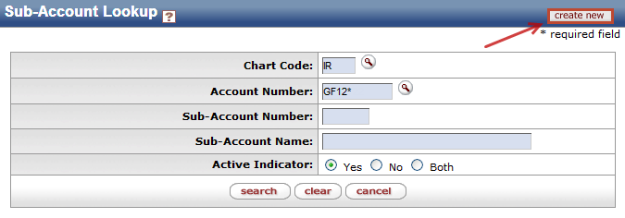
4 | 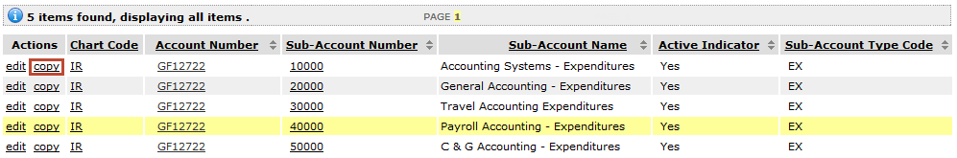  Complete eDoc | When the search results are displayed, users can create a new Sub-Account by selecting the copy link for the selected Sub-Account. KFS will automatically copy information from the existing Sub-Account to a new Sub-Account eDoc. Users can then edit the auto-populated information before submitting the eDoc.
5 | Save and Submit eDoc | Once data entry is complete, save and submit the Sub-Account eDoc.

