Quick Start Guide: Account Global Maintenance eDoc
Summary: The Account Global maintenance eDoc is used to assign identical attributes to multiple accounts on a single document. For example if an organization would like to add one Fiscal Officer to multiple accounts they would use the Account Global maintenance eDoc. The following is a list of account attributes that can be modified and submitted to workflow via the Account Global Maintenance eDoc :
Fiscal Officer , Account Supervisor , Account Manager, Organization Code, Sub-Fund Group Code, Account Expiration Date, Continuation Chart of Accounts Code, Continuation Account Number, Income Stream Chart Of Accounts Code, Income Stream Chart Of Accounts Number, CFDA Number, Higher Education Function Code, Account Sufficient Funds Code, Transaction Processing Sufficient Funds Check.
Watch the video – Account Global Maintenance eDoc.

Steps | What you need to do | How to do it
1 | Access KFS via Zot Portal | - Use your UCInetID and password to log in to https://portal.uci.edu/  - Press the Faculty and Staff tab and then select the KFS tab  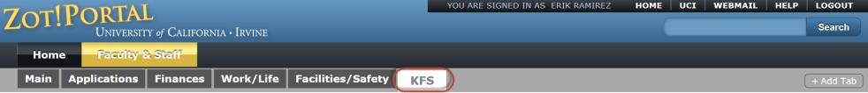
2 | Access Account Global | - Navigate to the KFS Lookups & Requests portlet  - Expand the Chart of Accounts bullet  - Select Account Global  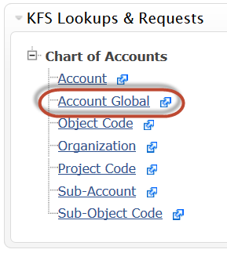
3 | Enter the new Account information  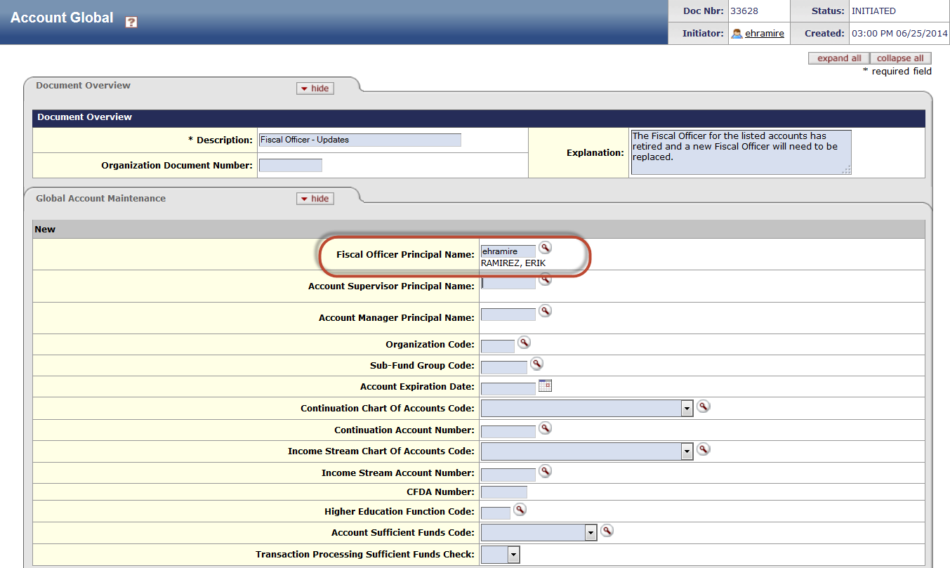 | - In the Document Overview tab complete the required Description field  - In the New section enter the account attributes you want applied to all accounts that you will select in the next section (Edit List of Accounts)  Example: Enter the Fiscal Officer’s UCInetID in the Fiscal Officer Principal Name field. If the UCInetID is unknown select the magnifying glass icon and conduct a Person Lookup.
4 | 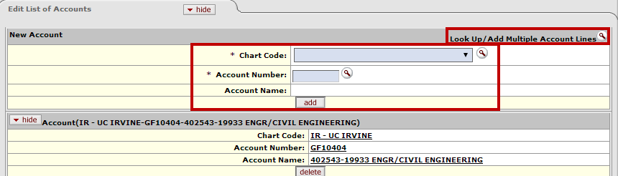  Access Edit List of Accounts tab | - Manually enter each Chart Code and Account Number in the New Account section and select the add button  or  - Look up to add multiple Account lines by selecting the magnifying glass icon
5a  Optional  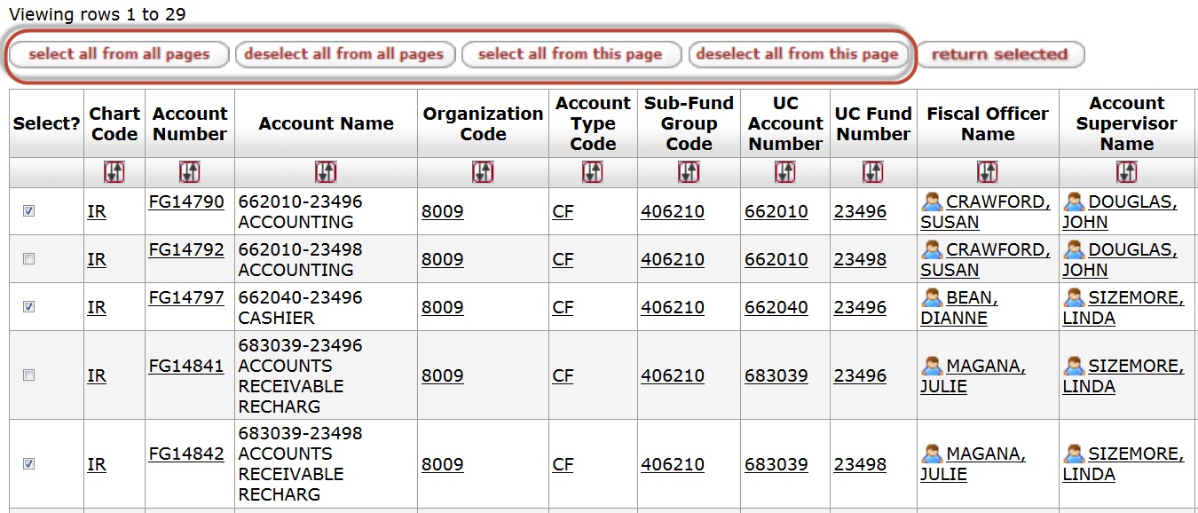  5b  Optional | Look Up and Add Multiple Account Lines | - Select the Look Up/Add Multiple Account lines icon to display the Account lookup screen  - Mark the check box in the Select? column or choose one of the action buttons shown below to select the accounts that you wish to be updated
5c  Optional | 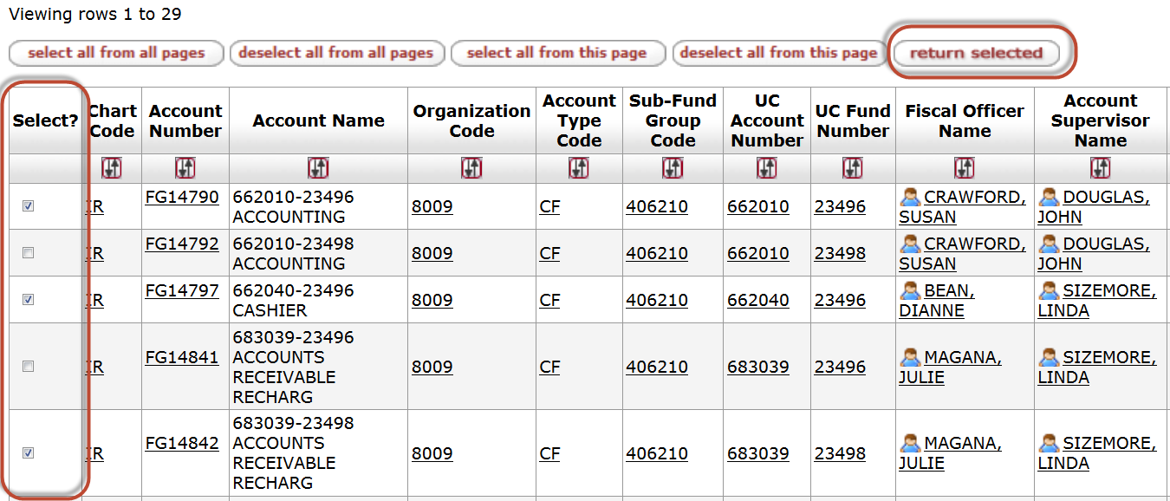  Return Selected Accounts | After the desired accounts have been selected users can press the return selected button to return the results to the Account Global Maintenance eDoc
6 | 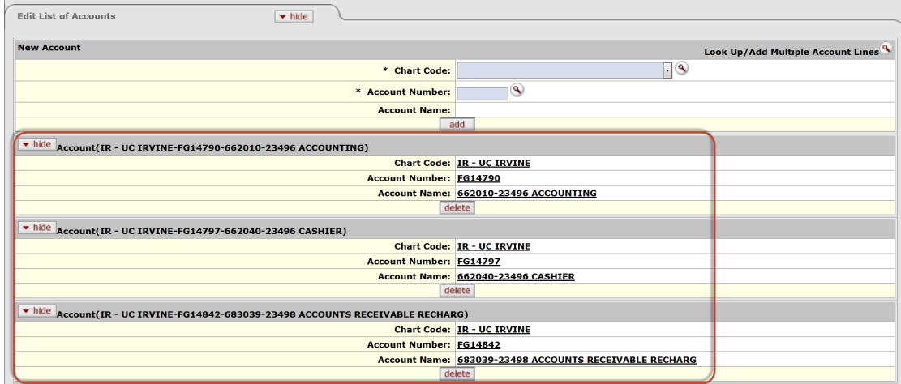  Verify added accounts | - Verify that all accounts have been added
7 | Review and Submit eDoc | - After reviewing the changes, press the Submit button at the bottom of the eDoc  - The eDoc will be submitted to workflow and the status will change from Initiated to Enroute
8 | Review Route Log tab | - To review additional eDoc information (Actions Taken, Future Action Requests or to Log Action Messages) select the Route Log tab

