Quick Start Guide: Action List Filter
Summary: The KFS Action List has a filter feature to select Action List items you may wish to view. This is useful if you have a large Action List and need to find a particular document, or view a specific type of document. The ‘exclude’ feature filters out document types you don’t need to view.
Steps | What you need to do | How to do it
1 | Access KFS via ZOTPortal | - Use your UCInetID and password to log in to https://portal.uci.edu/  - Press the Faculty and Staff tab and then select the KFS tab
2 | Access Action List | - From the KFS Tools portlet, select Action List  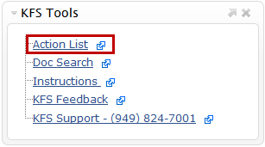
3 | Open the Action List filter to select a document type | - Select the filter button to open the Action List Filter  - In Document Type, select the , the magnifying glass icon, to find a document  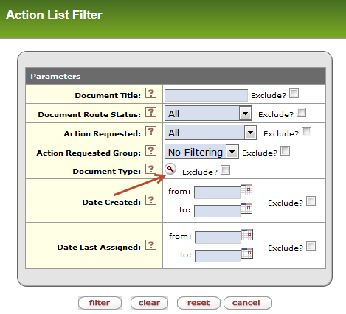
4 | Search for Document Type to select in filter | - Enter the Document abbreviated name in the Name field  - For example, enter PCDO for Procurement Card Transaction Document (PALCard)  - Press the search button  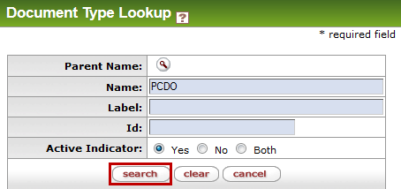
5 | Filter the Document Type | - Select return value next to the Document Type you wish to filter  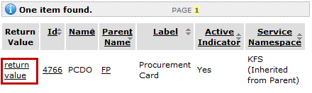
6 | Complete the filter setup in the action list | - If you want to view only the document type selected, skip Step 6.2  - If you want to see all documents, except the one selected, check the Exclude indicator checkbox  - Selecting the Exclude checkbox will exclude all documents of this type from view in the Action List.  - Not selecting the checkbox will show only that document type in the Action List  - Select the filter button to be taken back to the Action List  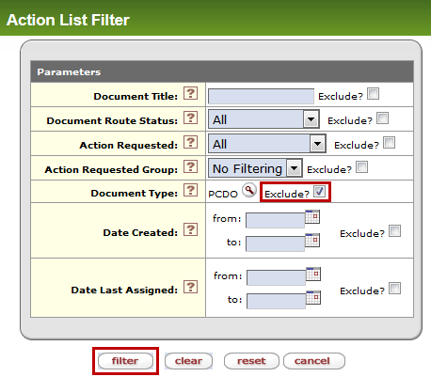
Optional | Remove filters from Action List | - From the Action List, select the clear filter button to remove all filters and view all documents in your Action List

