Quick Start Guide: Change Fiscal Officer For Multiple Accounts
Summary: KFS organizations are responsible for the maintenance of Fiscal Officers on all accounts within their Organization. In the event a Fiscal Officer leaves or no longer oversees an account, organizations will be responsible for ensuring that the Fiscal Officer is replaced.
The Account Global maintenance eDoc is used to assign identical attributes to multiple accounts on a single document. For example if an organization would like to add one Fiscal Officer to multiple accounts they would use the Account Global maintenance eDoc.
Steps | What you need to do | How to do it
1 | Access KFS via Zot Portal | - Use your UCInetID and password to log in to https://portal.uci.edu/  - Press the Faculty and Staff tab and then select the KFS tab  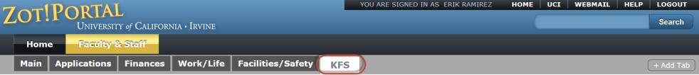
2 | Access Account Global | - Navigate to the KFS Lookups & Requests portlet  - Expand Chart of Accounts  - Select Account Global  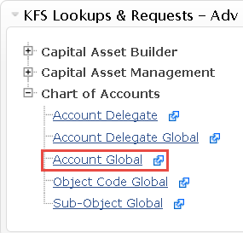
3 | Enter required information  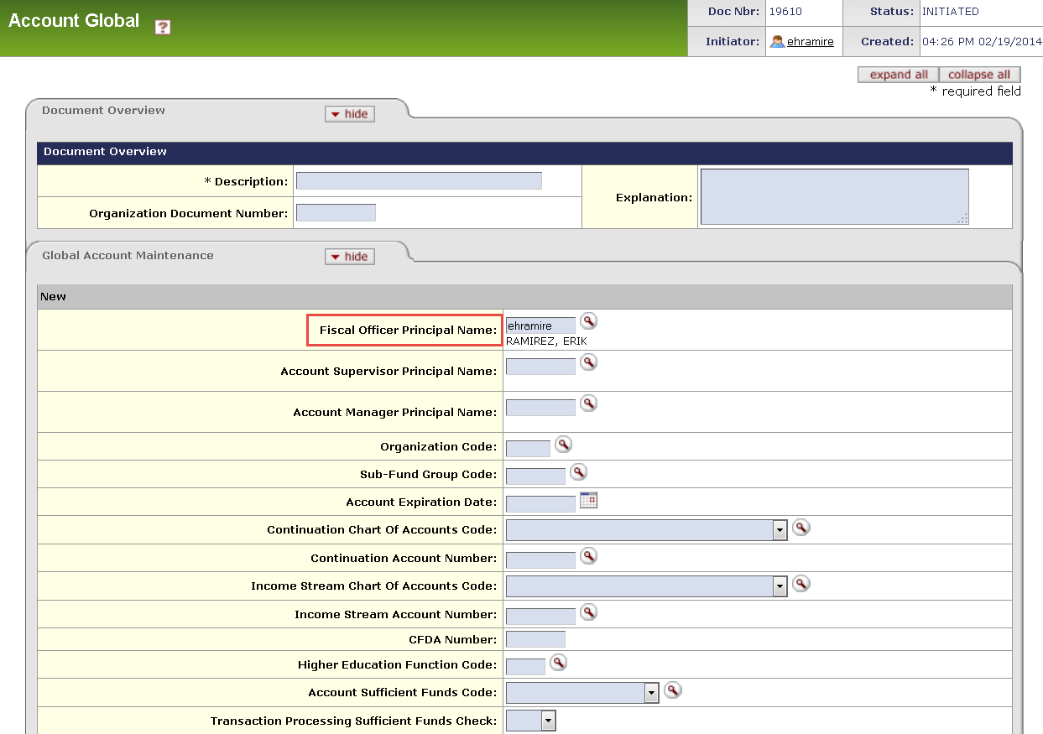 | - In the Document Overview tab complete the required Description field  - In the Global Account Maintenance section, enter the UCInetID for the new Fiscal Officer in the Fiscal Officer Principal Name field. If the UCInetID is unknown select the magnifying glass icon to initiate a Person Lookup
4 | 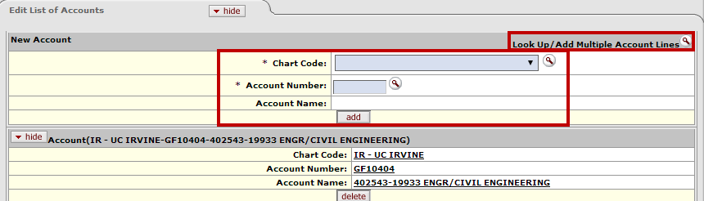  Access the Edit List of Accounts tab | - Manually enter each account in the New Account section or  - Perform a Look up to add multiple account lines by selecting the magnifying glass icon
5  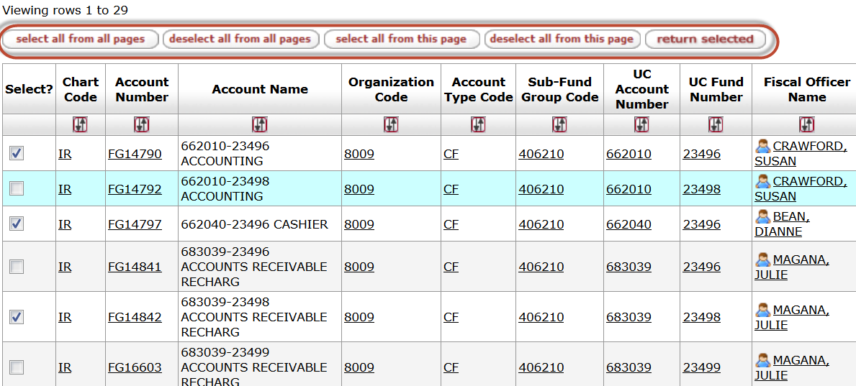  5 | Perform a Look Up to Add Multiple Account Lines | - Select the Look Up/Add Multiple Account Lines to open Account lookup  - On the Account Lookup Screen, enter the name of the old Fiscal Officer to pull up all accounts assigned. You may mark each check box in the Select? column or select the button for all accounts or all accounts showing on the current page.  - Select desired accounts and then press return selected button to return the results to the Account Global Maintenance eDoc
6 | Verify added accounts | - Verify all accounts that will be changed to the new Fiscal Officer
7 | Review and Submit eDoc | - After reviewing the changes, press Submit button at the bottom of the eDoc  - The eDoc will be submitted to workflow and the status will change from initiated to Enroute
8 | Review Route Log tab | Upon submission the Account Maintenance eDoc will go through workflow for review and approval  Required Approvals for Account Maintenance eDoc: Organization Reviewer, Chart Manager (IR), University Chart Manager (UC)

