Quick Start Guide: Change The Fiscal Officer (FO) for one Account
Summary: Fiscal Officers are the workflow approvers responsible for the daily oversight and approval of KFS financial transaction eDocs. They are assigned to all KFS Accounts and are responsible for checking financial transactions for accuracy. When a Fiscal Officer needs to be changed (per account, not globally), users will initiate the Account maintenance document.
KFS Organizations are responsible for the maintenance of Fiscal Officers on all accounts within their Organization. In the event a Fiscal Officer leaves or no longer oversees an account, Organizations will be responsible for ensuring that the FO is replaced in KFS before further items route to their Action List.
Steps | What you need to do | How to do it
1 | Access KFS via ZOTPortal | - Use your UCInetID and password to log in to https://portal.uci.edu/  - Press the Faculty and Staff tab and then select the KFS tab  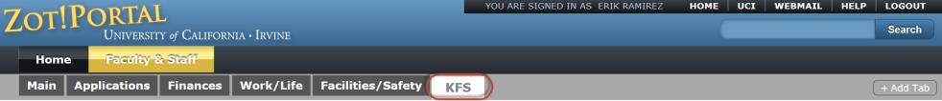
2 | Access Account | 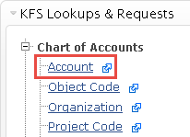  - Navigate to the KFS Lookups & Requests portlet  - Expand the Chart of Accounts bullet  - Select Account
3 | Locate Account | - You have several options to find the account for editing:  a. Enter the UC Account Number in the UC Account Number field  - You can query your new KFS Account number using the old account and fund information.  - In the event both the KFS Account Number and UC Account and Fund are unknown, locate the KFS Account using other search parameters e.g., Account Name, Organization Code, Account Type Code, current Fiscal Officer, etc.  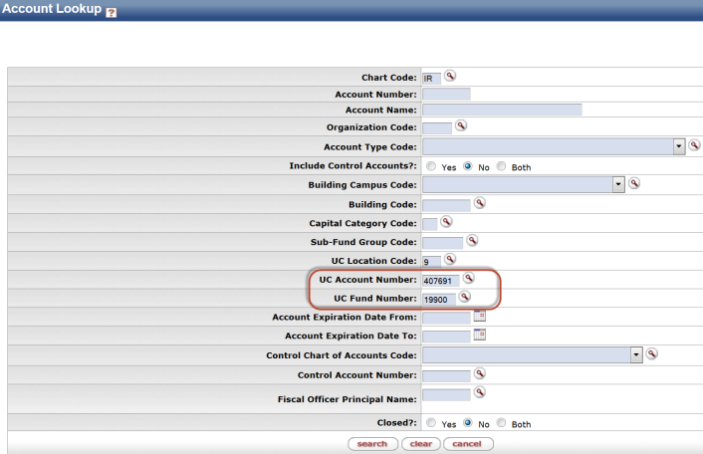
4 | Search | - Press the search button at the bottom of the Lookup screen, once the criteria has been entered, in order to return and review the results
5 | Select edit for the account being changed  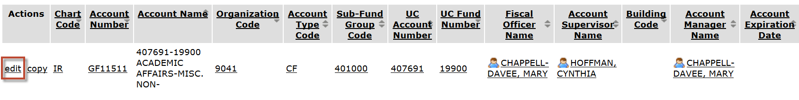 | - When you have reviewed the search results, select the edit link to open the appropriate Account Maintenance eDoc
6 | Complete the Document Overview tab | - Enter a brief description of the transaction, e.g. replacing a Fiscal Officer  - Add a detailed Explanation of the transaction (recommended)  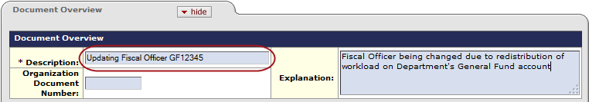
7 | Update the Fiscal Officer Principal Name | - Navigate to the Account Responsibility tab  - In the New section, enter the Fiscal Officer’s UCInetID in Fiscal Officer Principal Name field. If the UCInetID is unknown, select the magnifying glass icon to initiate a Person Lookup.  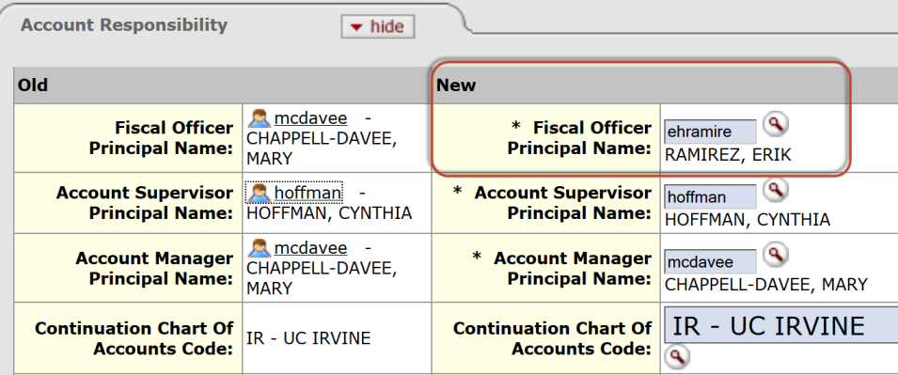
8 | Review and Submit eDoc | - Scroll to the bottom of the document and press the Submit button  - The eDoc will be go through electronic workflow for approvals and the status will change from Initiated to Enroute
9 | Review Route Log tab for status | - Upon submission the Account Maintenance eDoc will go through workflow for review and approval.  Approvals for Account Maintenance eDoc:  - New Fiscal Officer on Account  - Account Supervisor (FYI)  - Current Fiscal Officer on Account  - General Accounting Reviewer  - Chart Manager (campus based)  - University Chart Manager (UC)

