Quick Start Guide: Create an Organization
Summary: The Organization eDoc defines the representing units at many different levels within our University (for example, a department, responsibility center, campus). This document collects important identifying information about an Organization and defines its place in the organization hierarchy. The concept of “organization” in the KFS chart of accounts has a different meaning than in our previous financial system (FS). The term will define units at any level within the University hierarchy. In KFS, all departments, units will be called organizations, or “orgs”. This structure gives departments the flexibility to set up orgs in a way that best facilitates their unique information and reporting needs.

Steps | What you need to do | How to do it
1 | Access KFS via ZotPortal | - Go to https://portal.uci.edu/  - Log in with your UCInetID and password  - Click on the Faculty and Staff tab  - Select the KFS tab  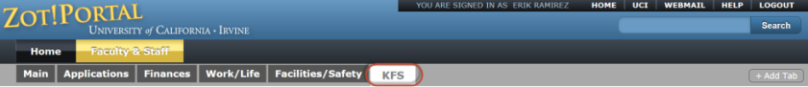
2 | Access the Organization item | - Navigate to the KFS Lookups & Requests portlet  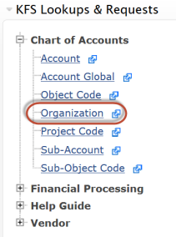  - Expand the Chart of Accounts bullet  - Click on the Organization item
3 | Perform an Organization Lookup | Option 1- Perform an Organization Lookup and copy a similar existing organization. In this Quick Start Guide we will be selecting Option 2.  Or  Option 2- To create a new Organization select the “create new” button located at the top right corner of the Organization Lookup screen (This option requires users to enter all fields from scratch).  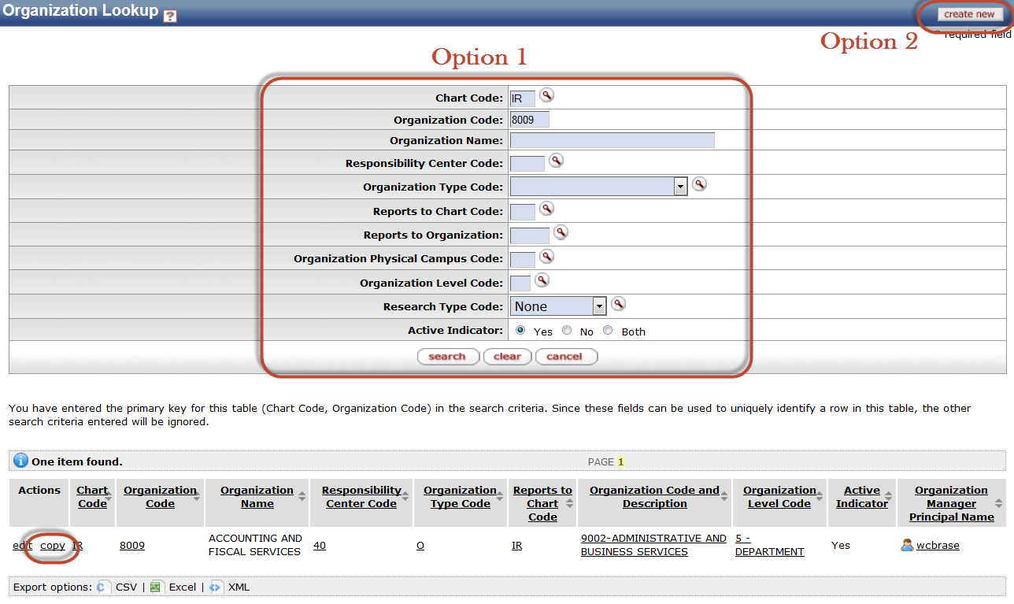
 | Select Action Copy | Navigate to the Actions column of the results page and select the copy link  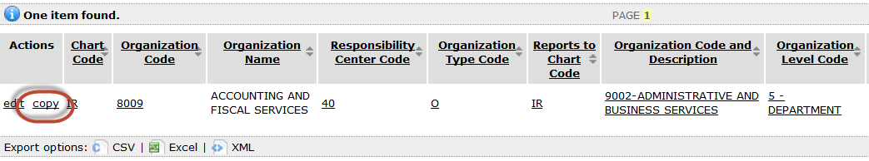
 | Complete the Document Overview tab | - Enter a brief description of the transaction, e.g. Creating a New Organization  - Add a detailed Explanation of the transaction (recommended)
 | Complete the Edit Organization Code tab | Review and make adjustments to the New required Org field attributes  Example: Chart Code, Organization Code, Organization name  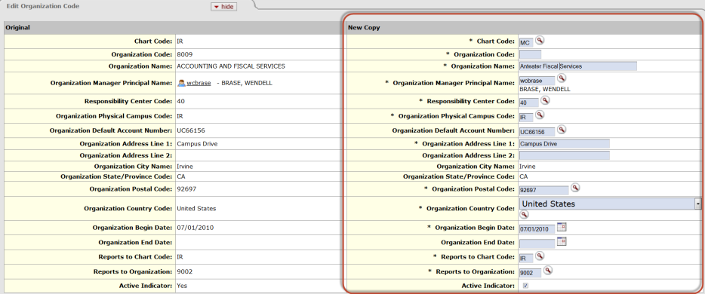
 | Ignore remaining tabs | Ignore the remaining tabs:  - Edit Budget Attributes  - Edit Plant Accounts  - Edit Medical Center Plant Account (Memo Entry)  Note: For more information about the Organization eDoc and these tabs click on the document help icon located at the top of your screen
 | Submit request | - Press the Submit button  - If you’re curious to know who will ultimately vet this request, visit the Route Log tab:  - Under the Pending Action Requests and Future Action Requests tab you will see a list of individuals who will receive this item in their Action Lists

