Quick Start Guide: Look up Account
Summary: The Account Lookup function enables users to search accounts in the system database based on specified parameters. Any user can look up any account, regardless of account-specific permissions, because only non-sensitive account information is displayed in the search results.
Steps | What you need to do | How to do it
1 | Access KFS via ZOTPortal | - Use your UCInetID and password to log in to https://portal.uci.edu/  - Press the Faculty and Staff tab and then select the KFS tab
2 | Access Account | - From to the KFS Lookups and Request portlet, expand the Chart of Accounts bullet  - Select Account
3 | 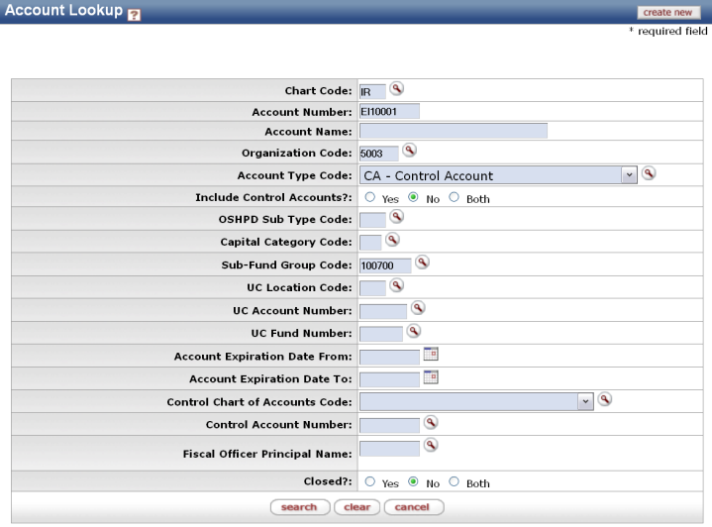  Search | - Enter desired search criteria  Note: Users can search with partial information by placing an asterisk (*) before and/or after the portion of the search criteria known  - Press search button once you’ve entered the desired search criteria
4 | Review search results  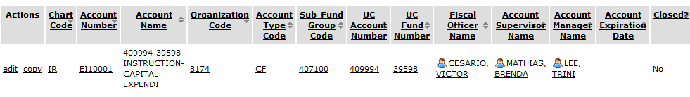 | Sort items by selecting the titles in the header above the results

