Quick Start Guide: Look up an Account Type
Summary: All KFS Accounts have an associated Account Type code. The Account Type code is an attribute of a KFS Account that identifies the type or source of the funds.
Replacement: The FS AF-Account table will be replaced by the KFS Account Type Lookup.
Steps | What you need to do | How to do it
1 | Access KFS via ZOTPortal | - Use your UCInetID and password to log in to https://portal.uci.edu/  - Press the Faculty and Staff tab and then select the KFS tab
2 | Access Account Type | - Navigate to the KFS Lookups and Request portlet  - Expand the Chart of Accounts bullet  - Select Account  - Navigate to the Account Type Code field and press the magnifying glass icon on the right
3 | 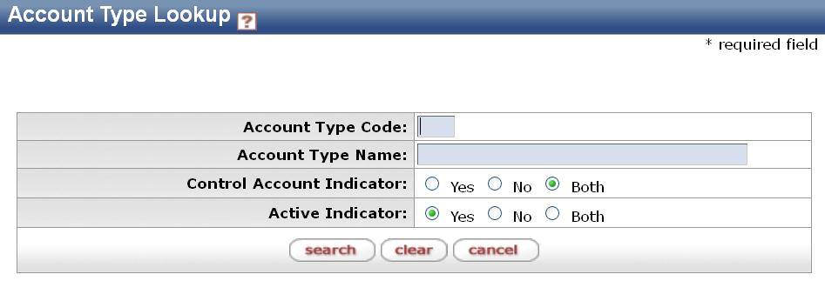  Enter search criteria | - Enter desired search criteria  Note: You can search with partial information by placing an asterisk (*) before and/or after the portion of the search criteria  - Press search button once you’ve entered the desired search criteria
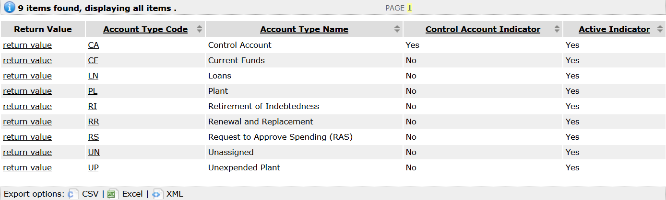  4 | Review search results | - Sort items by selecting the titles in the header above the results

