Quick Start Guide: Look up an Asset Number
Summary: An asset number is a system-assigned identifier unique to the asset. Users responsible for the maintenance of campus assets known as Asset Representatives will use the asset number lookup to find their assets. Once an asset number is found, the asset status, location, and other information can be updated.
Replacement: The KFS Asset Number Lookup replaces the EQS Asset Lookup.
Steps | What you need to do | How to do it
1 | Access KFS via ZOTPortal | - Use your UCInetID and password to log in to https://portal.uci.edu/  - Press the Faculty and Staff tab and then select the KFS tab
2 | Access the Asset item | - From the KFS Capital Asset Management portlet, select the Asset item.  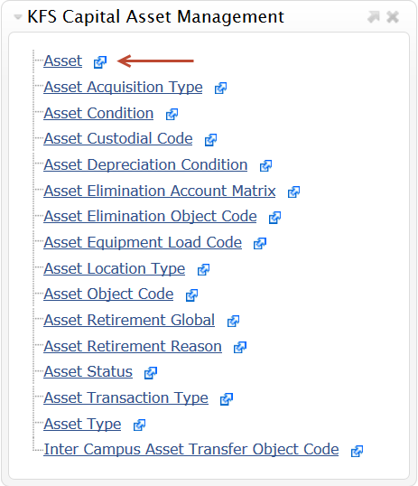
3 | 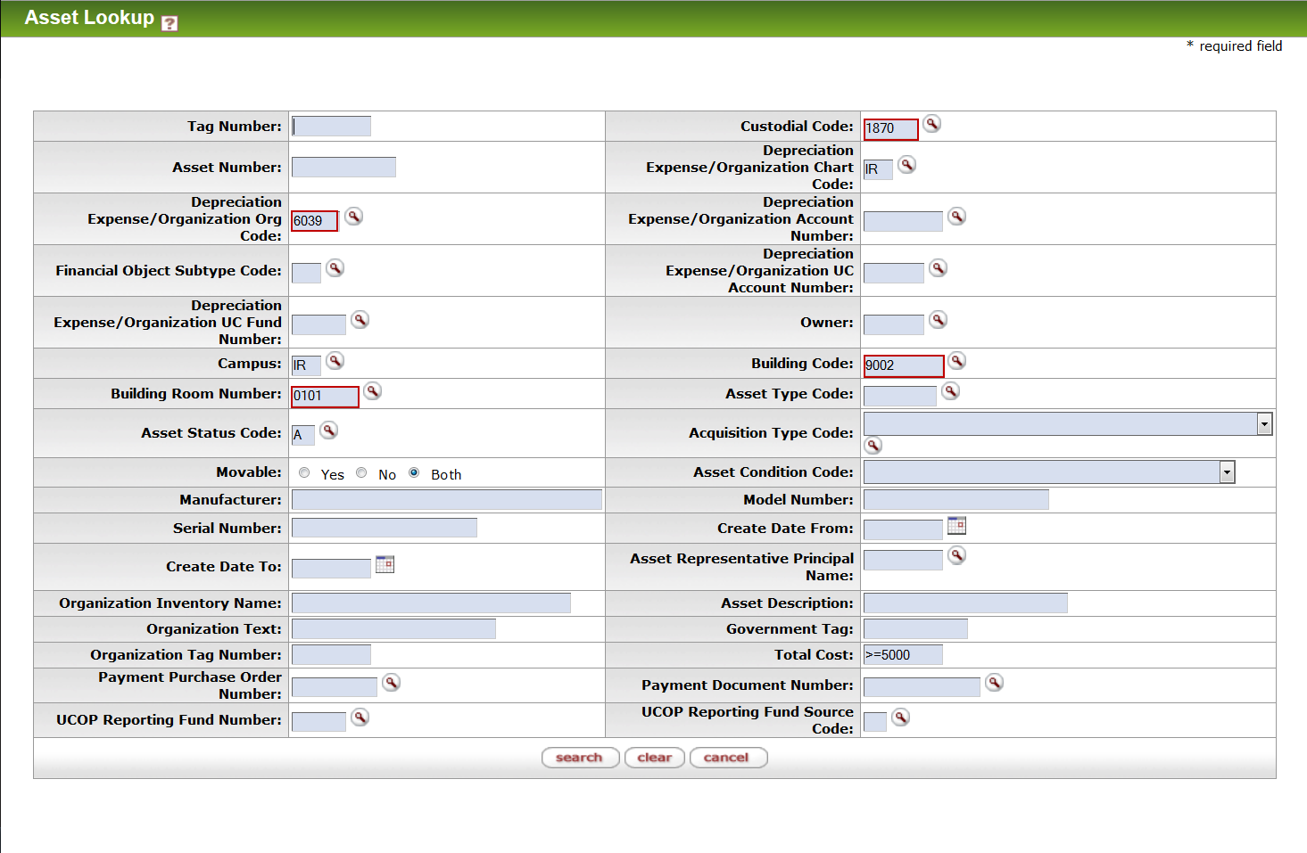  Search | - Enter desired search criteria  - Complete more fields to narrow down the results. Using the custodial code is a quick way to find assets.  Note: Users can search some fields using only partial information by placing an asterisk (*) before and after the text portion of the search criteria  - 2. Press the Search button once you’ve entered your search criteria
4 | 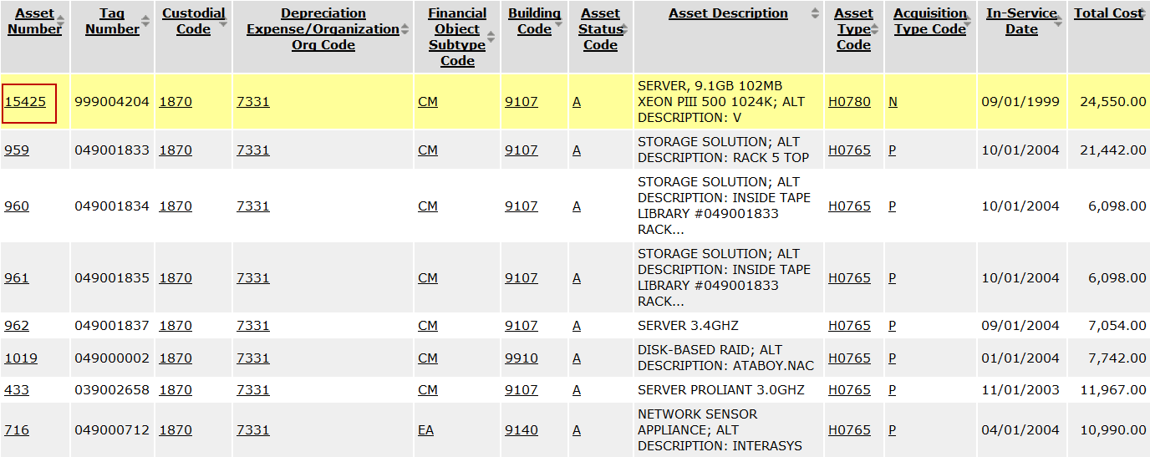  Select the Asset | 1. Select the asset number of the asset that you would like to update

