Quick Start Guide: Look up Available Balances
Summary: Results for the Available Balances inquiry show budget, actual, encumbrance, and variance by object code. For expenses, variance equals budget, less actual encumbrance. For revenues, variance equals actual, less budget. You may view either consolidated or detailed results, which segregate sub-accounts and sub-object codes.
Replacement: KFS Balance Inquiries replaces GLI and FS0100.
Steps | What you need to do | How to do it
1 | Access KFS via ZOTPortal | - Use your UCInetID and password to log in to https://portal.uci.edu/  - Press the Faculty and Staff tab and then select the KFS tab
2 | Access Available Balances | - Navigate to the KFS General Ledger portlet  - Select Available Balances  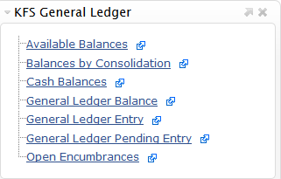
3 | Search | - Enter desired search criteria  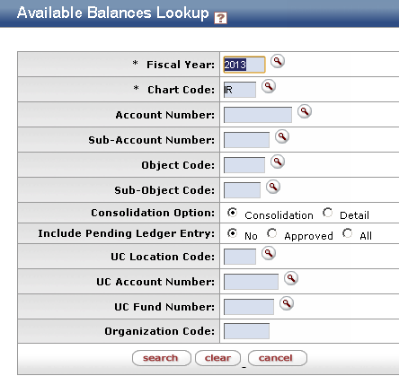  Note: Users can search some fields using only partial information by placing an asterisk (*) before and after the text portion of the search criteria  - Press the search button once you’ve entered your search criteria
4 | 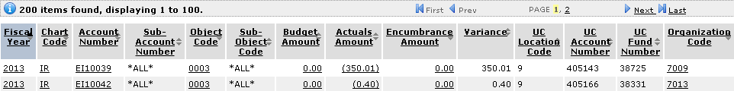  Review search results | Sort items by selecting the titles in the header above the results

