Quick Start Guide: Look up An Award
Summary: The Award Document has the same information currently found in FS tables. Under the Award Details tab you can find: the proposal number, agency award number (Root Award Number), Stop Date (Period of Performance End Date), UC fund number, Project Title, Start Date (Period of Performance Begin Date), Total Award Amount (the total amount of the award, not specific accounts), Fund Manager Name (Central Contracts and Grants Accountant assigned to that fund) and other information.
Replacement: FS Fund tables
Steps | What you need to do | How to do it
1 | Access KFS via ZOTPortal | - Use your UCInetID and password to log in to https://portal.uci.edu/  - Press the Faculty and Staff tab and then select the KFS tab
2 | Access the Award item | 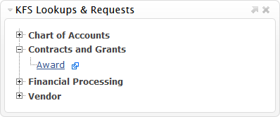  - From the KFS Lookups & Requests portlet expand the Contracts and Grants bullet.  - Select Award
3 | 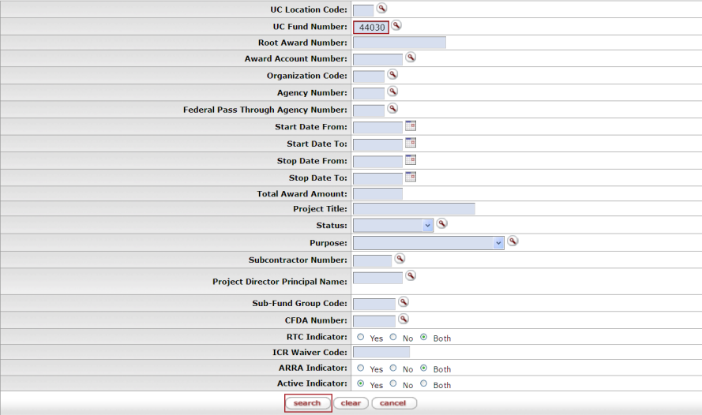  Enter search criteria | - Enter desired search criteria  Note: Users can search some fields using only partial information by placing an asterisk (*) before and after the text portion of the search criteria  The UC Fund number can be used to search for an Award  - Press the search button once you’ve entered your search criteria
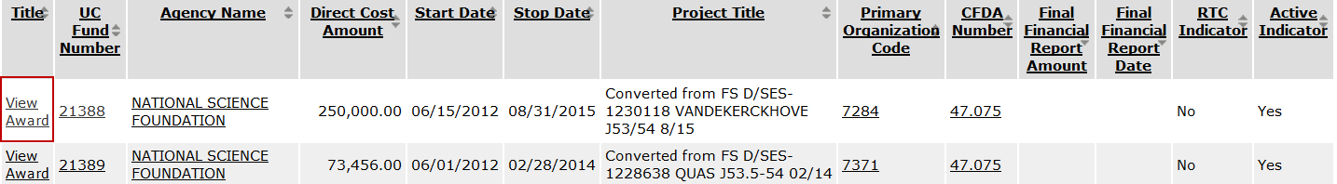  4 | Choose an Action | Select View Award link to review the desired Award

