Quick Start Guide: Look up Balances by Consolidation
Summary: Results for the Balances by Consolidation inquiry show budget, actual, encumbrance, and variance by account consolidation, based on the Consolidation Object levels. For expenses, variance equals budget, less actual, less encumbrance. For revenues, variance equals actual, less budget.
Replacement: KFS Balance Inquiries replaces GLI and the FS0150.
Steps | What you need to do | How to do it
1 | Access KFS via ZOTPortal | - Use your UCInetID and password to log in to https://portal.uci.edu/  - Press the Faculty and Staff tab and then select the KFS
2 | Access Balances by Consolidation | - Navigate to the KFS General Ledger portlet  - Select Balances by Consolidation  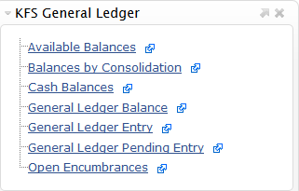
3 | Search | - Enter desired search criteria  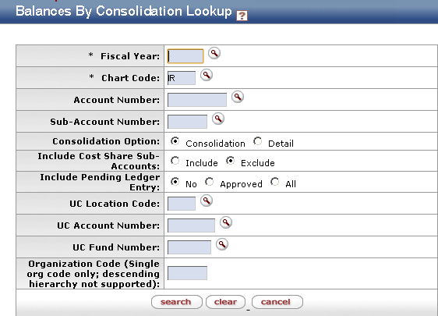  Note: Users can search some fields using only partial information by placing an asterisk (*) before and after the text portion of the search criteria  - Press the search button once you’ve entered the search criteria
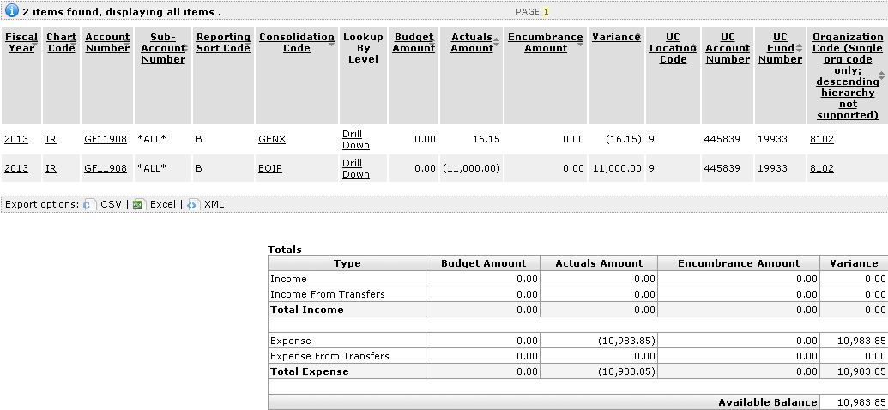  4 | Review search results | Sort items by selecting the titles in the header above the results

