Quick Start Guide: Look up Custodial Code
Summary: The Custodial Code is a number that identifies the Organization responsible for an asset.
Replacement: This is part of the Capital Asset Management (CAM) module which replaces EQS and Equipment Inventory Modification Requests (EIMR).
Steps | What you need to do | How to do it
1 | Access KFS via ZOTPortal | - Use your UCInetID and password to log in to https://portal.uci.edu/  - Press the Faculty and Staff tab and then select the KFS tab
2 | Access Asset | - From the KFS Capital Asset Management portlet.  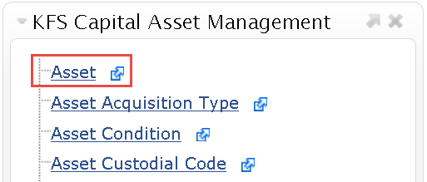  - Select Asset
3 | 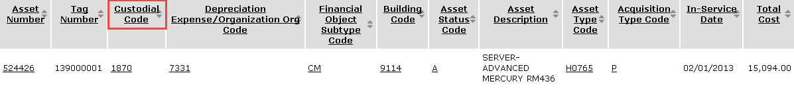  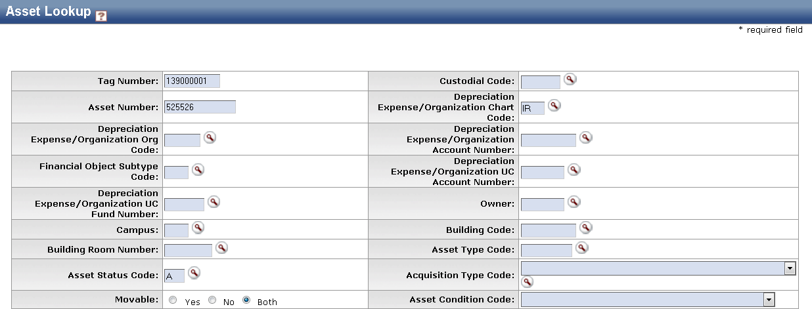  Enter search criteria | Enter the Tag Number or the Asset Number to display the Custodial Code in the search results  Note: If the Tag Number and Asset Number are unknown, users can select the Asset Custodial Code Lookup (see *Alternate 3 below)
*Alternate  3 | 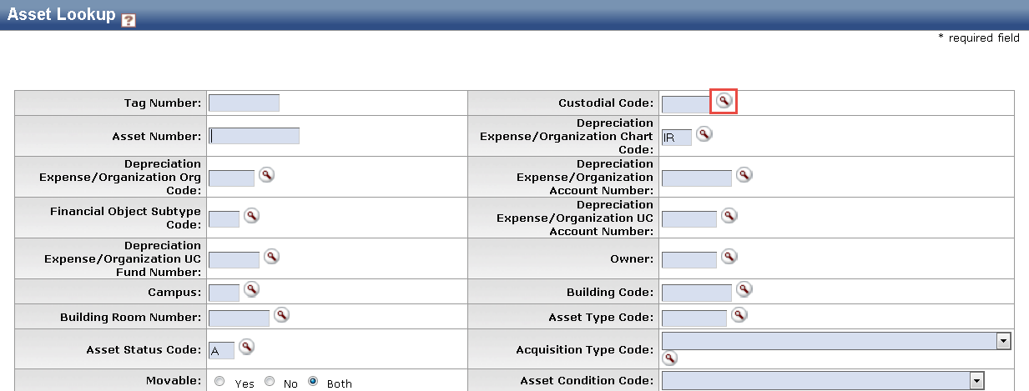  Look up Custodial Code | Select the magnifying glass icon in the Custodial Code field
4 | 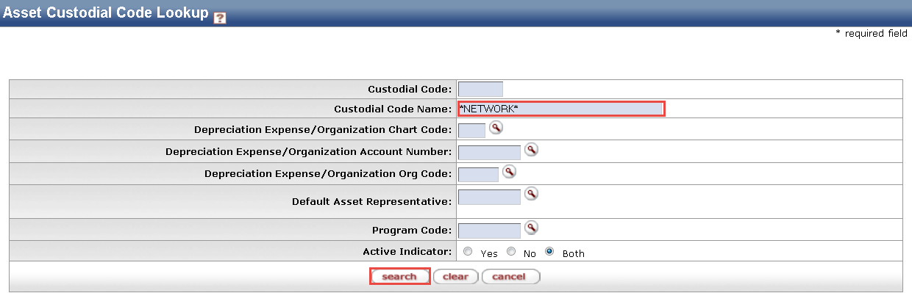  Search | Enter desired search criteria  Note: Users can search some fields using only partial information by placing an asterisk (*) before and after the text portion of the search criteria
5 | Search | Press the Search button once you’ve entered your search criteria
6 | 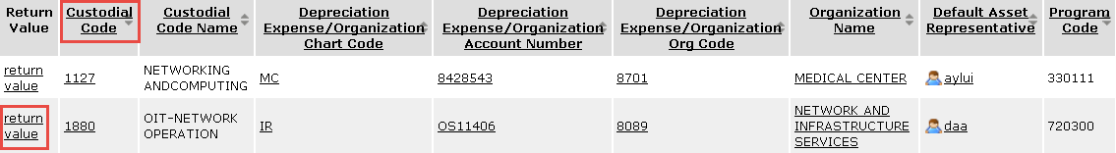  Select Custodial Code | Press Return Value option and select the appropriate Custodial Code

