How to look up an Entertainment Reimbursement (ENT)
Summary: This document instructs KFS users how to perform a Lookup for a submitted Entertainment Reimbursement (ENT) eDoc in KFS.

Note: The KFS Entertainment Reimbursement (ENT) Lookup restricts search results to only those ENT documents for which the user is an authorized viewer (initiator, arranger, Fiscal Officer, AP, etc.).

Steps | What you need to do | How to do it
1 | Access KFS TEM via ZOTPortal | - Navigate and log in to the ZOTPortal website on a UC Irvine network connected computer: https://portal.uci.edu  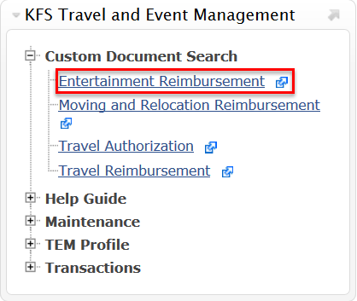  - Select the Faculty & Staff Super Tab  - Select the KFS tab  - Scroll to the KFS Travel and Event Management portlet  - Click the Custom Document Search bullet  - Click the Entertainment Reimbursement item  - The ENT Document Search will automatically open
2 | Perform a Detailed Search for the ENT | - Select the detailed search button to allow for more fields to search the ENT eDoc
3 | 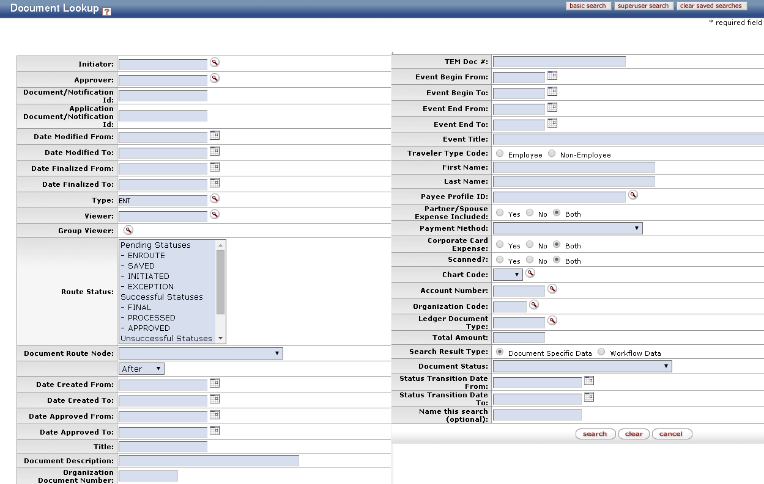  Enter Search Criteria and Search | - Enter desired search criteria in any of the fields below  Note: Some fields allow for the use of the asterisk (%) as a search qualifier, to search for partial names  - Select Yes for the Scanned? Indicator to only retrieve scanned documents back.  - Select the route status: “Enroute” to only view documents that have not been finanlized and are still in workflow.  - Select the search button, once search criteria have been entered  - Results will be displayed on the bottom, and can be sorted or narrowed down further by inputting more search criteria

