Quick Start Guide: Look up Fund Group
Summary: The KFS Fund Group is used to define the broadest category of funds and is used for reporting and business rules.
Replacement: The KFS Fund Group Lookup replaces the FS FG-Fund Group and FN-Fund table browse.
Steps | What you need to do | How to do it
1 | Access KFS via ZOTPortal | - Use your UCInetID and password to log in to https://portal.uci.edu/  - Press the Faculty and Staff tab and then select the KFS tab
2 | Access Fund Group | - Navigate to the KFS Lookups & Requests-Adv portlet.  - Expand the Chart of Accounts bullet  - Select Fund Group  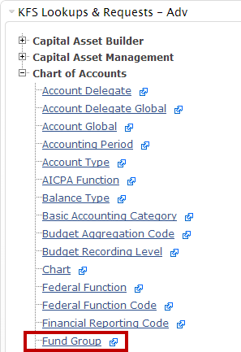
3 | Search | - Enter desired search criteria  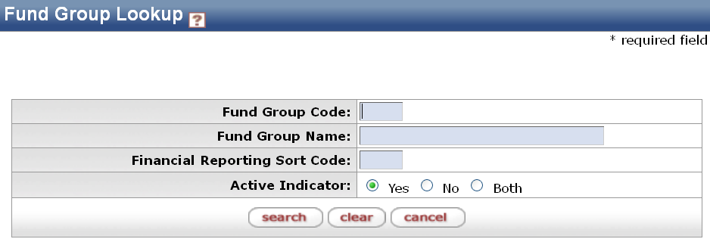  Note: You can search with partial information by placing an asterisk (*) before and/or after the portion of the search criteria  - Press the search button once the desired search criteria have been entered
4 | Review search results | - Sort items by selecting the titles in the header above the results  