Quick Start Guide: Look up General Ledger Balance
Summary: The General Ledger Balance inquiry shows an account's object code balances for each month of the fiscal year. Similar to some of the other KFS online inquiry screens, the user can drill down into the balances to view transaction detail and individual e-docs.
Replacement: KFS Balance Inquiries replaces GLI and the FS0150.
Steps | What you need to do | How to do it
1 | Access KFS via ZOTPortal | - Use your UCInetID and password to log in to https://portal.uci.edu/  - Press the Faculty and Staff tab and then select the KFS tab
2 | Access General Ledger Balance | - Navigate to the KFS General Ledger portlet  - Select General Ledger Balance  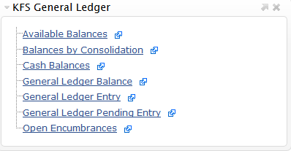
3 | 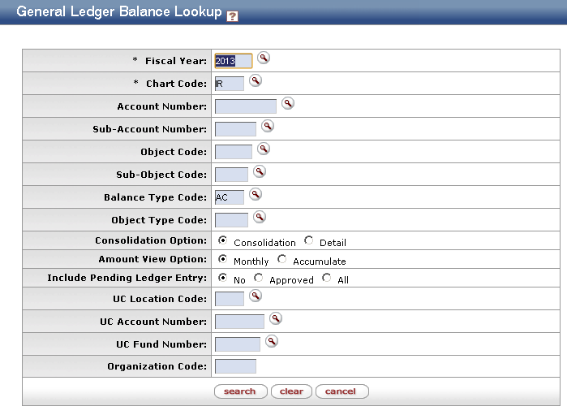  Search | - Enter desired search criteria  Note: Users can search some fields using only partial information by placing an asterisk (*) before and after the text portion of the search criteria  - Press the search button once you’ve entered your search criteria
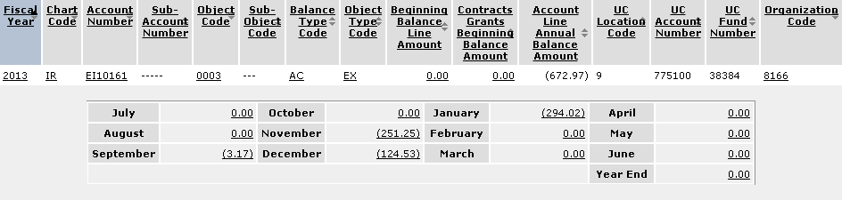  4 | Review search results | Sort items by selecting the titles in the header above the results

