Quick Start Guide: Look up General Ledger Entry
Summary: The General Ledger Entry inquiry displays the individual transactions that make up the balance in an account. It is the same inquiry that can be displayed by drilling down into the General Ledger Balance report, but instead of drilling down from the General Ledger Balance screen you can go directly to this report by selecting it from the main Balance Inquiries menu.
Replacement: KFS General Ledger Entry replaces GLI and the FS0100.
Steps | What you need to do | How to do it
1 | Access KFS via ZOTPortal | - Use your UCInetID and password to log in to https://portal.uci.edu/  - Press the Faculty and Staff tab and select the KFS tab
2 | Access General Ledger Entry | 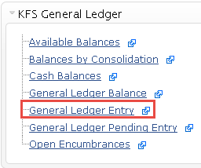  - From the KFS General Ledger portlet, select the General Ledger Entry item.
3 | Search  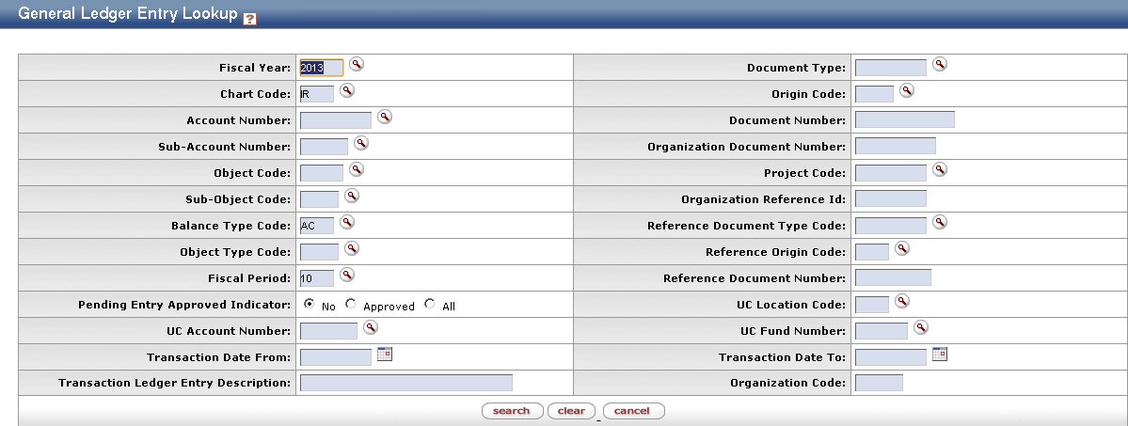 | - Enter desired search criteria  Note: Users can search some fields using only partial information by placing an asterisk (*) before and after the text portion of the search criteria  - Press the search button once you’ve entered your search criteria
4 | Review search results | Users can sort items by selecting the titles in the header above the results.

