Quick Start Guide: Look up General Pending Ledger Entry
Summary: The General Ledger Pending Entry lookup is identical to the General Ledger Entry lookup except that it displays General Ledger Pending Entry transactions. Transactions are pending until the document has moved through the approval process and the GL batch posting job has run.
Replacement: N/A
Steps | What you need to do | How to do it
1 | Access KFS via ZOTPortal | - Use your UCInetID and password to log in to https://portal.uci.edu/  - Press the Faculty and Staff tab and then select the KFS tab
2 | Access General Ledger Pending Entry | - Navigate to the KFS General Ledger portlet  - Select General Pending Ledger Entry  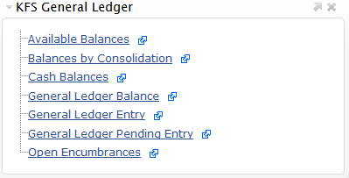
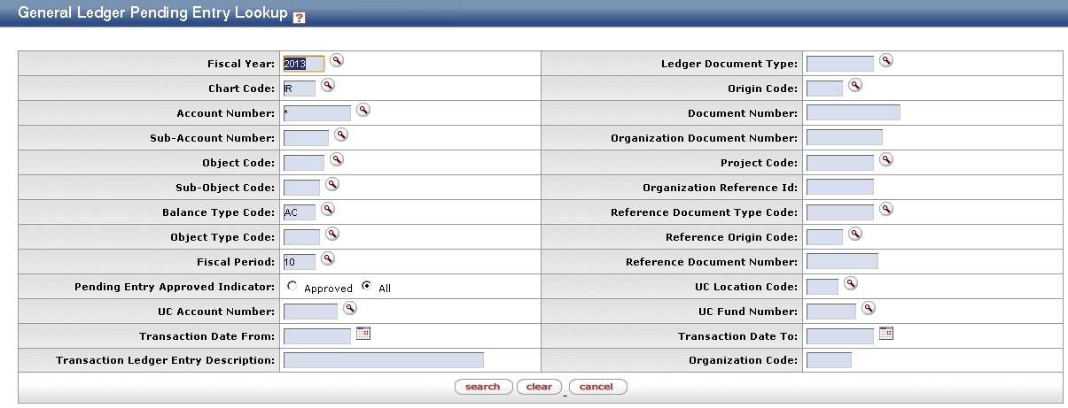  3 | Search | - Enter desired search criteria  Note: Users can search some fields using only partial information by placing an asterisk (*) before and after the text portion of the search criteria  - Press the search button once you’ve entered your search criteria
4 | Review search results | Users can sort items by selecting the titles in the header above the results

