Quick Start Guide: Look up Moving and Relocation (RELO) Reimbursement
Summary: The Moving and Relocation Reimbursement (RELO) document allows users to track moving and relocation expenses and create vendor payments and reimbursements for these expenses. The RELO Lookup will be especially useful in researching General Ledger expenses or payee/payment information for RELO documents. The Related Documents tab of the RELO document will also lead users to any associated Disbursement Voucher (DV) and/or other related document(s).
Note: The KFS Moving and Relocation Reimbursement (RELO) Lookup restricts search results to only those RELO documents for which the user is an authorized viewer, that is, anyone who is on the route log or is an reimbursement arranger.
Steps | What you need to do | How to do it
1 | Access KFS via ZOTPortal | - Use your UCInetID and password to log in to https://portal.uci.edu/  - Press the Faculty and Staff tab and select the KFS tab
2 | Access Moving and Relocation Reimbursement | - From the KFS Travel and Event Management portlet, expand the Custom Document Search bullet  - Select Moving and Relocation Reimbursement
3 | Search | Enter desired search criteria  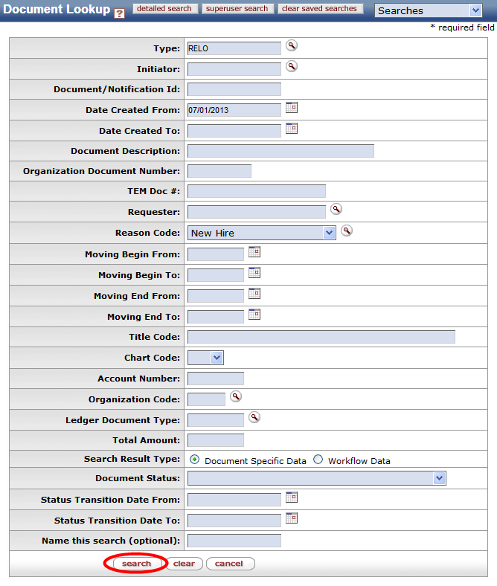  Note: Users can search with partial information by placing an asterisk (*) before and/or after the portion of the search criteria known
4 | Search | Select search once you have entered your search criteria
5 | Review Search Results | Sort items by selecting the titles in the header above the results

