Quick Start Guide: Look up Object Codes
Summary: Object Codes represent all income, expense, asset, liability, and fund balance classifications that are assigned to transactions, and help identify the nature of the transaction. Object Codes are specific to a chart and a fiscal year, and contain several attributes throughout the KFS for financial reporting, at the detail and consolidated levels.
Replacement: The KFS Object Codes Lookup replaces the GL Table.
Steps | What you need to do | How to do it
1 | Access KFS via ZOTPortal | - Use your UCInetID and password to log in to https://portal.uci.edu/  - Press the Faculty and Staff tab and then select the KFS tab
2 | Access Object Code | - From the KFS Lookups and Request portlet, expand the Chart of Accounts bullet  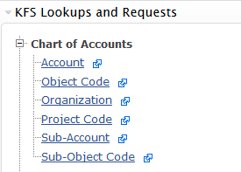  - Select Object Code
3 | Search | - Enter desired search criteria  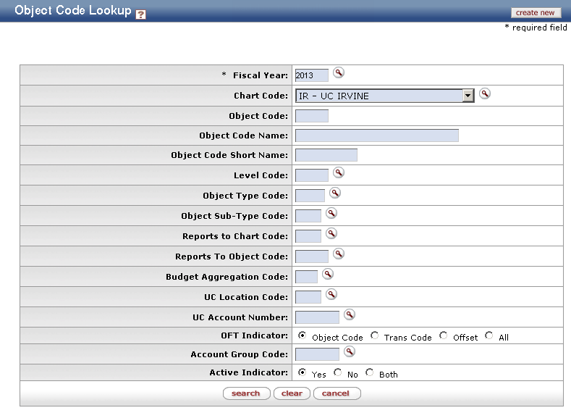  Note: Users can search some fields using only partial information by placing an asterisk (*) before and after the text portion of the search criteria  - Press the search button once you’ve entered your search criteria
4 | Review search results  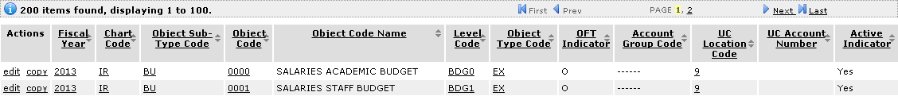 | Sort items by selecting the titles in the header above the results

