Quick Start Guide: Look up Open Encumbrances
Summary: The Open Encumbrances Lookup displays the detail for open encumbrances. You must enter the fiscal year, chart, and account number, or the fiscal year and document number. The values you may choose from the encumbrance report include external encumbrance (EX), internal encumbrance (IE), and pre-encumbrance (PE). External encumbrances are those that are owed externally to entities outside your institution, such as a purchasing system or travel system. Internal encumbrances represent things owed internally to the institution, such as encumbrances from a payroll system integrated with the KFS. Pre-encumbrances are established within the KFS via the Pre-encumbrance document.
Replacement: In the FS system, users go to the General Ledger Inquiry (FS0100) function to view open encumbrances. In KFS, users will go to the Open Encumbrance function to view encumbrances.
Steps | What you need to do | How to do it
1 | Access KFS via ZOTPortal | - Use your UCInetID and password to log in to https://portal.uci.edu/  - Press the Faculty and Staff tab and then select the KFS tab
2 | Access Open Encumbrances | - Navigate to the KFS General Ledger portlet  - Select Open Encumbrances  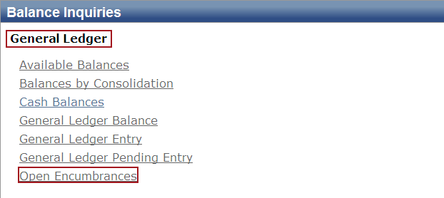
3 | 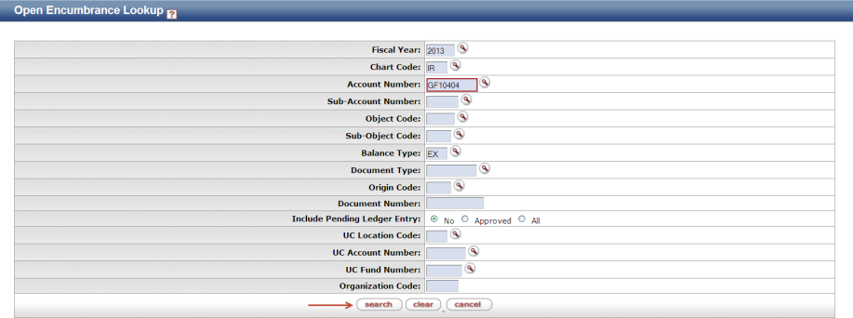  Search | - Enter desired search criteria  Note: Users can search some fields using only partial information by placing an asterisk (*) before and after the text portion of the search criteria  - Press the search button once you’ve entered your search criteria
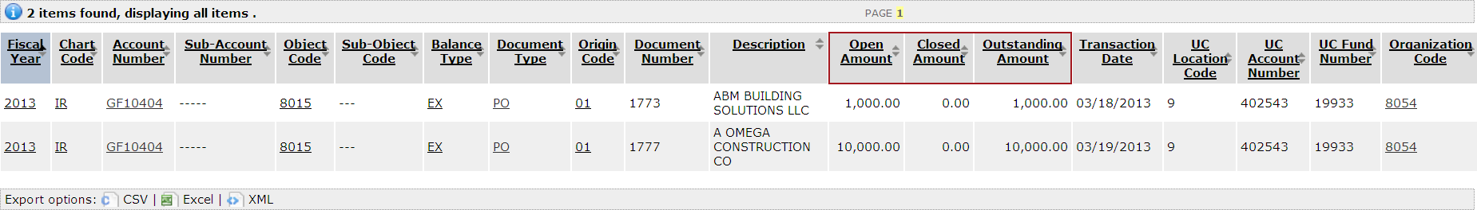  5 | View encumbered items | - The open amount reflects the total amount of the encumbrance for this document number  and  - The closed amount reflects the amount of that encumbrance relieved to date

