Quick Start Guide: Look up an Organization
Summary: The Organization document defines the entities representing units at many different levels within the institution, e.g. department, responsibility center, campus. The document collects important identifying information about an Organization and defines its place in the organization hierarchy. Organization is an important part of the Chart of Accounts and the organization hierarchy is frequently leveraged by the KFS for use in Workflow and reporting.
Replacement: The KFS Organization Lookup replaces Org Table
Steps | What you need to do | How to do it
1 | Access KFS via ZOTPortal | - Use your UCInetID and password to log in to https://portal.uci.edu/  - Press the Faculty and Staff tab and then select the KFS tab
2 | Access Organization | 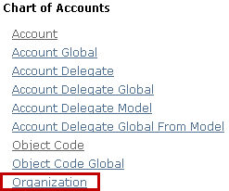  - From the KFS Lookups and Request portlet expand the Chart of Accounts bullet  - Select Organization
3 | Search | - Enter desired search criteria:  - Enter IR in Chart Code field  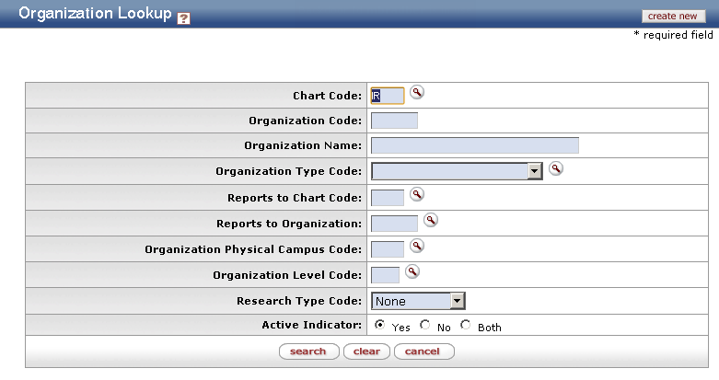  Note: Users can search some fields using only partial information by placing an asterisk (*) before and after the text portion of the search criteria  - Press the search button once you have entered search criteria  - Complete more fields to further refine your search
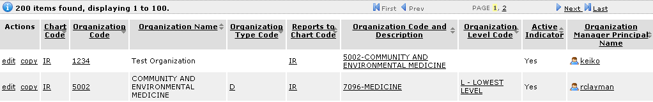  4 | Review search results | Sort items by selecting the titles in the header above the results

