Quick Start Guide: Look up PCDO eDocs (PALCard Review Documents)
Summary: The document search tool in KFS is the only way to lookup PALCard review documents (known as a PCDO). Otherwise, PCDOs will only appear in a user’s action list when an action is needed by them.
Replacement: The KFS document search for PCDO eDocs (part of the Financial Processing Module) replaces the search section of TOEP PALCard Charge Review in Zeus.
Steps | What you need to do | How to do it
1 | Access KFS via ZOTPortal | - Use your UCInetID and password to log in to https://portal.uci.edu/  - Press the Faculty and Staff tab and then select the KFS tab
2 | Access Document Search | - Navigate to the KFS Tools portlet  - Select Doc Search
4 | Enter Document Type in the Basic Document Lookup | - Enter PCDO in (document) Type field  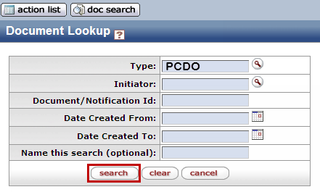  Note: Users can only do a basic search from at this point for an eDoc (based on Doc # & date range)  - Press the search button to display additional fields
5 | Search | - Enter desired search criteria (in the expanded search field criteria)  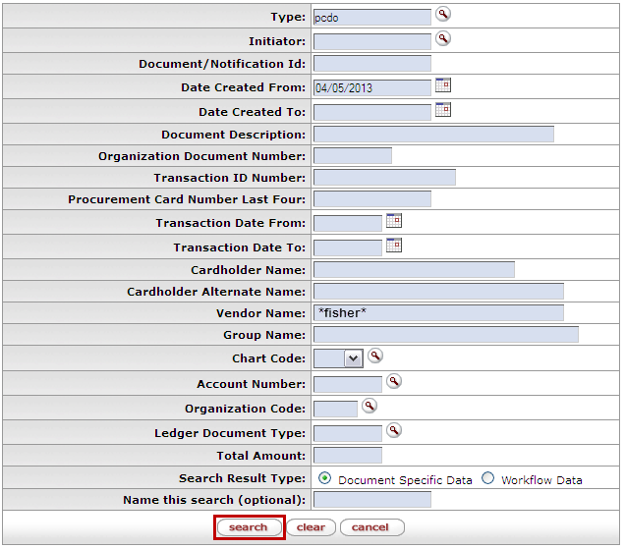  Note: Remember to change/delete the pre-filled Date Created From (if needed). Users can search some fields using only partial information by placing an asterisk (*) before and after the text portion of the search criteria  OR  See Alternate #5 below
*Alternate  5 | Access the Detailed Search link | 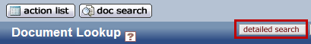  Select the Detailed Search button to open up more search field criteria

