Quick Start Guide: Look up a Payment Request (PREQ)
Summary: The most frequent searches for Payment Requests are available through the Custom Document Searches section. You can search with any combination of the available values and export the search results into CSV, Excel, or XML formats.
Replacement: KFS Payment Request (PREQ) Lookup replaces Invoice Activity (A38) in Zeus.
Steps | What you need to do | How to do it
1 | Access KFS via ZOTPortal | - Use your UCInetID and password to log in to https://portal.uci.edu/  - Press the Faculty and Staff tab and then select the KFS tab
2 | Access Payment Requests | - Navigate to the KFS Purchasing Accounts Payable portlet  - Expand the Custom Document Search bullet  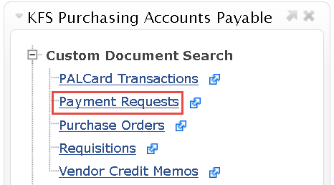  - Select Payment Requests
3 | Search | - Enter desired search criteria  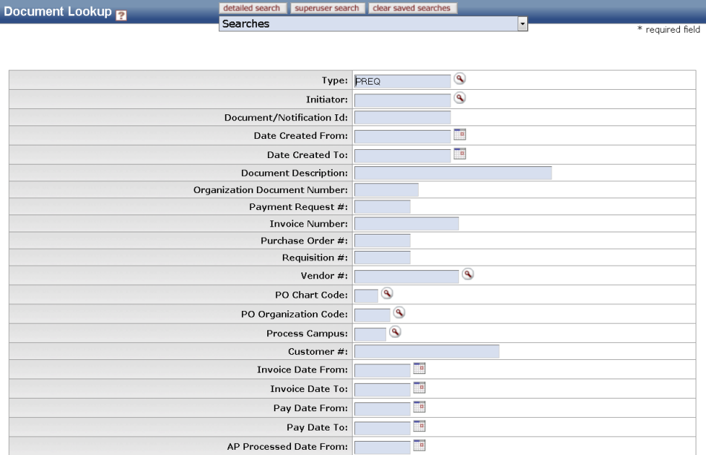  Note: You can search with partial information by placing an asterisk (*) before and/or after the portion of the search criteria known  - Press the search button once you’ve entered your search criteria
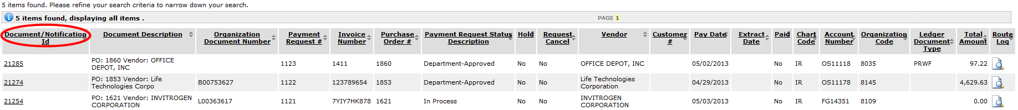  4 | Review search results | - Sort items by selecting the titles in the header above the results

