Quick Start Guide: Look up a Project Code
Summary: The Project Code document is used to define an optional part of the accounting string that allows you to assign an identifier to particular transactions that might span multiple accounts. Because the Project Code is not specific to an account, it can be used to track project activity that’s shared across multiple accounts within an organization, or even across multiple organizations.
Replacement: KFS Project Codes Lookup replaces Project Code Table.
Steps | What you need to do | How to do it
1 | Access KFS via Zot Portal | - Use your UCInetID and password to log in to https://portal.uci.edu/  - Press the Faculty and Staff tab and then select the KFS tab
2 | Access Project Code | - From the KFS Lookups and Requests portlet expand the Chart of Accounts bullet  - Select Project Code  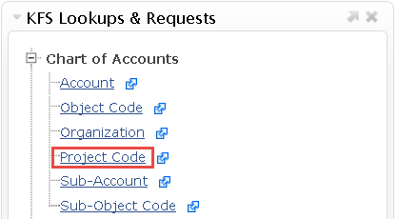
3 | Search  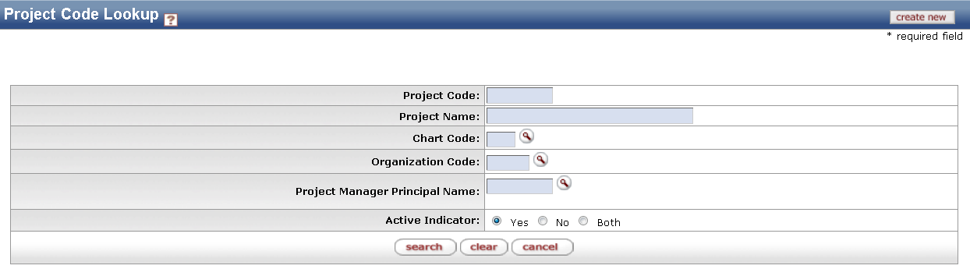 | - Enter desired search criteria  Note: Users can search some fields using only partial information by placing an asterisk (*) before and after the text portion of the search criteria  - Press the search button once you’ve entered your search criteria
4 | Review search results  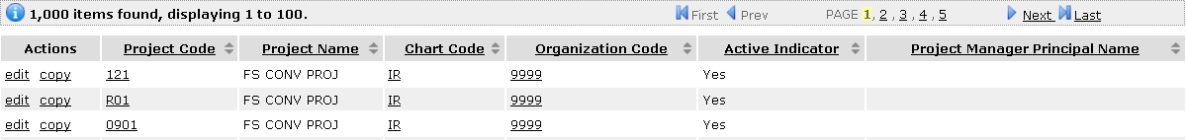 | Sort items by selecting the titles in the header above the results

