Quick Start Guide: Look up a Purchase Order
Summary: Looking up a Purchase Order (PO) is usually performed by Accounts Payable (AP) if a department or vendor has input a wrong/incomplete PO number on an invoice. When receiving an invoice from a vendor or department, AP must enter the PO# in order to create a Payment Request (PREQ). If the PO# does not appear, users can perform a Purchase Order search to find the original Purchase Order and/or the PO#.
Replacement: KFS PO Document Lookup search replaces the PAL PO order inquiry in Zeus.
Steps | What you need to do | How to do it
1 | Access KFS via ZOTPortal | - Use your UCInetID and password to log in to https://portal.uci.edu/  - Press the Faculty and Staff tab and then select the KFS tab.
2 | Access Purchase Orders | - From the KFS Purchasing Accounts Payable portlet, expand the Custom Document Search bullet  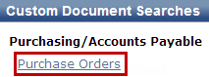  - Select Purchase Orders
3 | Search | - Enter desired search criteria  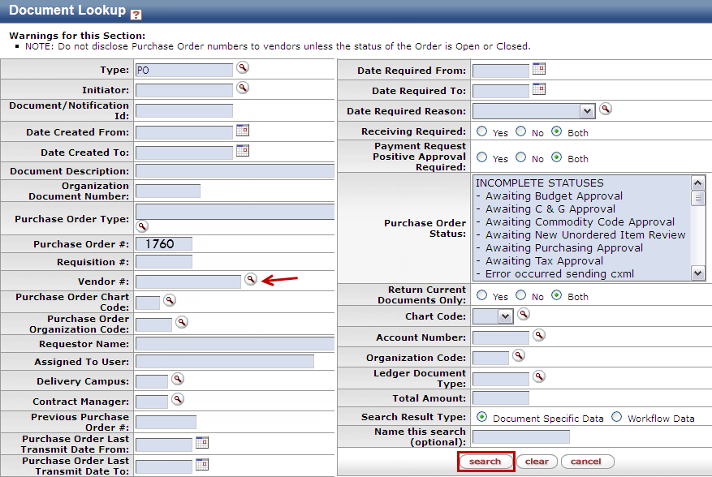  Note: Users can search some fields using only partial information by placing an asterisk (*) before and after the text portion of the search criteria. Users can also perform Lookups within lookups (see notes below)  - Press the search button once you’ve entered your search criteria
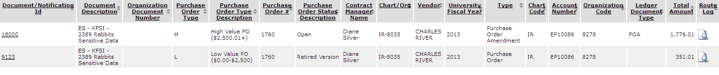  Notes | Lookups within Lookups | Select the lookup buttons next to select categories in order to be taken to another Lookup screen, which will return a certain value  Note: Select Vendor # to look up a vendor by name, in order to get the Vendor # and search PO based on Vendor

