Quick Start Guide: Look up Sub-Account
Summary: The KFS Sub-Account defines an optional part of the accounting string that tracks financial activity within a particular account in greater detail. Instead of associating budget, actuals, and encumbrances with an account, you can specify a sub-account within that account to apply these entries. Sub-accounts are often used to track expenses when several different activities may be funded by the same account.
Replacement: N/A
Steps | What you need to do | How to do it
1 | Access KFS via ZOTPortal | - Use your UCInetID and password to log in to https://portal.uci.edu/  - Press the Faculty and Staff tab and select the KFS tab
2 | Access Sub-Account | 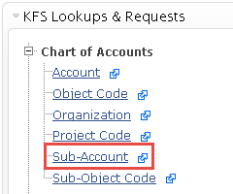  - From the KFS Lookups and Request portlet, expand the Chart of Accounts bullet  - Select Sub-Account
3 | 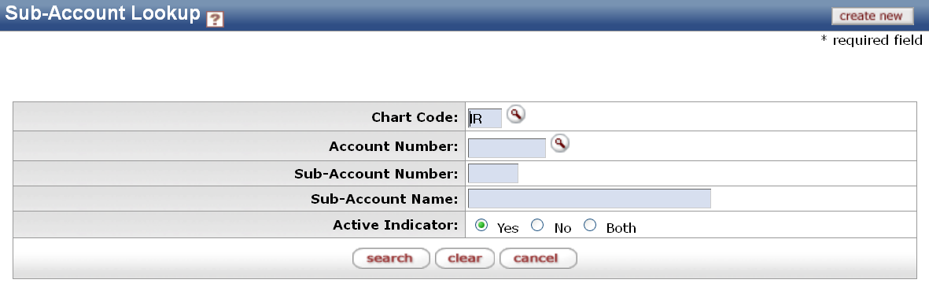  Search | - Enter desired search criteria  Note: Users can search with partial information by placing an asterisk (*) before and/or after the portion of the search criteria known  - Press search button once the desired search criteria has been entered
5 | Review search results | Select the titles in the header above the results to sort items

