Quick Start Guide: Look up Tag Number
Summary: A Tag number is an identification number issued by the university and affixed to the asset. To issue a loan, return or renew a document, the asset must have been assigned a tag number that was entered into the asset database. If the asset has not been tagged, it will not be available in the action list for asset loan, return, or renew.
Replacement: This part of the Capital Asset Management (CAM) module replaces EQS and Equipment Inventory Modification Requests (EIMR).
Steps | What you need to do | How to do it
1 | Access KFS via ZOTPortal | - Use your UCInetID and password to log in to https://portal.uci.edu/  - Press the Faculty and Staff tab and then select the KFS tab
2 | Access Asset | - Navigate to the KFS Capital Asset Management portlet.  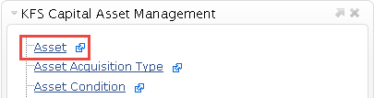  - Select Asset
3 | 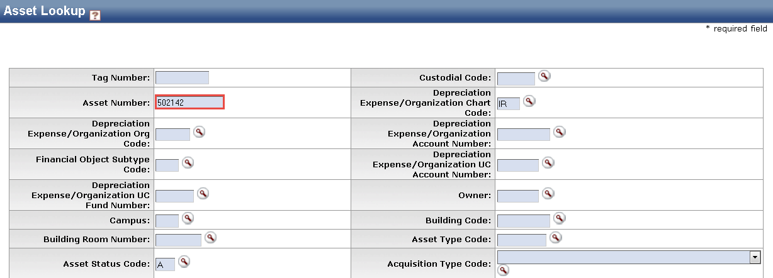  Search | - Enter desired search criteria  Note: Users can search some fields using only partial information by placing an asterisk (*) before and after the text portion of the search criteria  - Select the search button once you have entered your search criteria
4 | Select the information needed  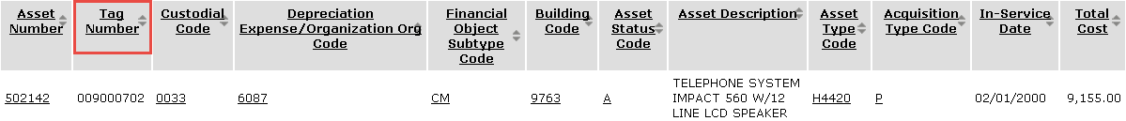 | Select the Asset Number of the Asset to be viewed

