Quick Start Guide: Look up Travel Authorization (TA)
Summary: You can use the Travel Authorization (TA) document to encumber planned travel expenses and process Travel Cash Advances for travelers. Use the TA Lookup to research open encumbrances and find an open TA from which to generate a Travel Reimbursement (TR). The Related Documents tab of the TA eDoc displays links to any associated eDoc(s) (TR, Disbursement Voucher (DV), etc.).
Note: The KFS Travel Authorization (TA) Lookup restricts search results to only those TA eDocs for which the user is an authorized viewer, that is, anyone who is on the route log or is an arranger.
Steps | What you need to do | How to do it
1 | Access KFS via ZOTPortal | - Use your UCInetID and password to log in to https://portal.uci.edu/  - Press the Faculty and Staff tab and then select the KFS tab
2 | Access Travel Authorization | - From the KFS Travel and Event Management portlet expand the Custom Document Search bullet  - Select Travel Authorization
3 | Search | - Enter desired search criteria  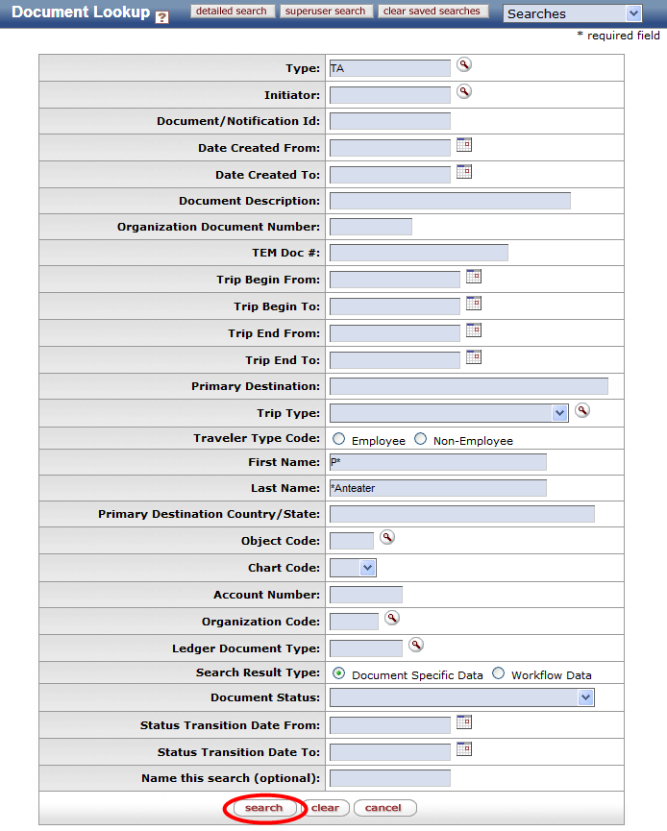  Note: Users can search with partial information by placing an asterisk (*) before and/or after the portion of the search criteria known. Entering “TA” into the type filed and clicking on search will expand the lookup screen to include travel specific search criteria  - Press search button once you’ve entered your search criteria
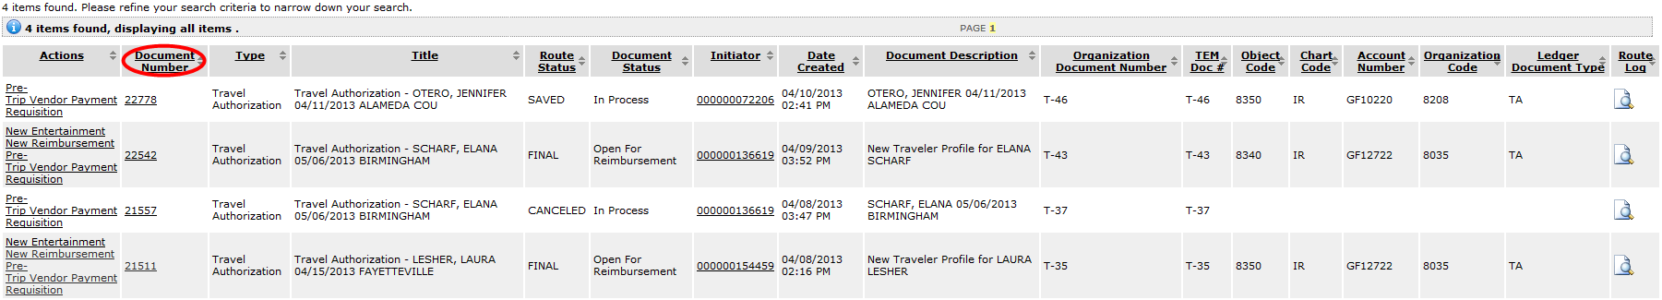  4 | Review search results | - Select the titles in the header to sort results

