Quick Start Guide: Look up Vendor
Summary: Accounts Payable (AP) and departments access Vendor Lookup to confirm vendor is valid in the KFS system and to edit their information. The Vendor search and edit option is open to all department and central users, but AP has final approval (the maintenance document passes through workflow).
Replacement: The KFS Vendor Lookup replaces the PAL vendor inquiry in Zeus.
Steps | What you need to do | How to do it
1 | Access KFS via ZOTPortal | - Use your UCInetID and password to log in to https://portal.uci.edu/  - Press the Faculty and Staff tab and then select the KFS tab
2 | Access Vendor | 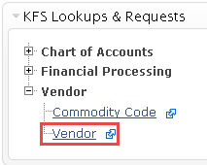  - From the KFS Lookups and Request portlet, expand the Vendor bullet  - Select Vendor
3 | Search  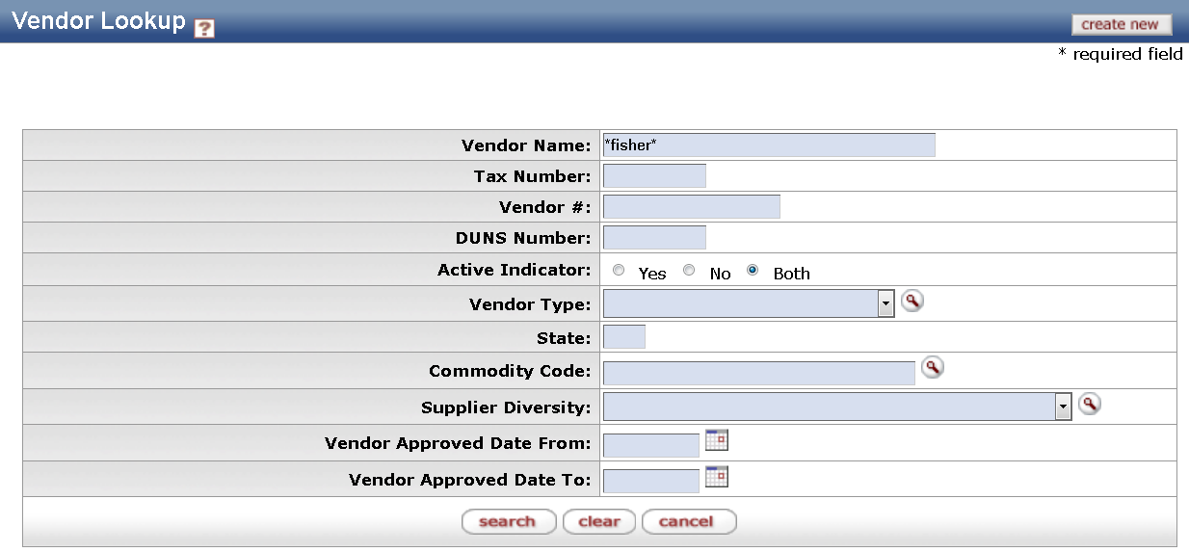 | - Enter desired search criteria, for example:  - Enter *fisher* in Vendor Name field  Note: Users can search some fields using only partial information by placing an asterisk (*) before and after the text portion of the search criteria  - Select the search button once you have entered your search criteria
4 | 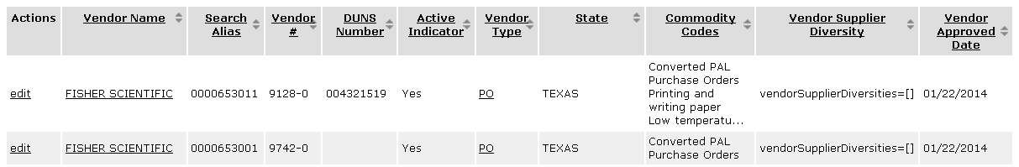  View or edit vendor information | - Select the result under Vendor Name for view-only access to the Vendor Inquiry screen for that vendor  - Select the Edit link under the Actions column to open the Vendor maintenance eDoc and to edit the vendor information (document is forwarded to Accounts Payable for final approval)

