Quick Start Guide: Look Up An Account Within A KFS eDoc
Summary: Perform an Account Lookup within a transactional eDoc. The Account Lookup is a tool used across multiple document types to find a KFS Account.

Notes: These instructions detail how to do a KFS Account Lookup (within a KFS eDoc) by the ‘old’ UC Account-UC Fund number, the account name, or by using other common search criteria.

Steps | What you need to do | How to do it
1 | In the KFS portal, open the Accounting Lines section of an eDoc | - You must first initiate and open a transactional eDoc  - Find instructions for filling out various types of eDocs on the UC Learning Center website  - Navigate to the Accounting Lines section of the eDoc  - Select the show button, if the tab or section is hidden  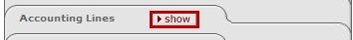 OR
2 | Use Account Lookup to complete the Accounting Lines section/tab  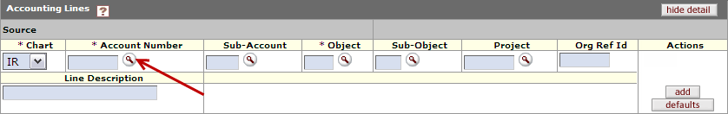 | - The Account Number field is used for the KFS Account Number.  - Enter the number if you know it and therefore do not need to search. (move on to Step 7)  - To find a KFS Account Number, select the (magnifying glass icon) next to that field  - An Account Lookup search will display.  The screen shot (below) is an example of how an Accounting Lines section appears. Some documents may include additional fields.
3 | Enter the correct Campus Code, according to the Chart of Accounts | 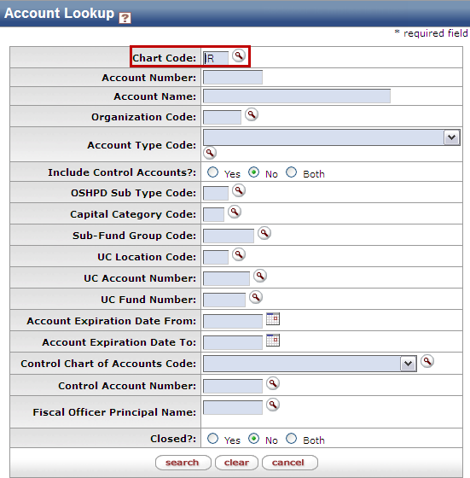  - Ensure that the Chart Code on the Account Lookup is correct  - This will default to what the initiator had selected in the Accounting Lines section, but can be changed  Examples:  IR= UC Irvine  MC= Medical Center  SW= System Wide  UC=University of California
4 | Search for a KFS Account:  Based on the UC Account and the UC Fund | - Next to the UC Account Number, enter the UC Account (6 digits)  - Next to the UC Fund Number, input the UC Fund (5 digits)  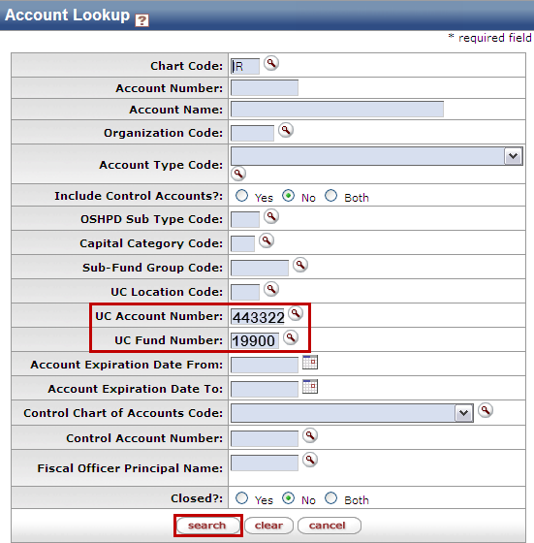  - Press the search button  Note: “Include Control Accounts” and include “Closed?” accounts in the search criteria default to “No”. If users want to include Control Accounts or closed accounts in their KFS searches, they should select “Yes” to only include them, or “Both” to include everything.
Alternate | Search for a KFS Account:  Based on the Account Name | - Next to the Account Name field, enter a portion of the KFS Account name as search criteria by using asterisks (*) as search qualifiers  - Press the search button  Note: Asterisks are a way to search in KFS if you don’t know an exact match for something  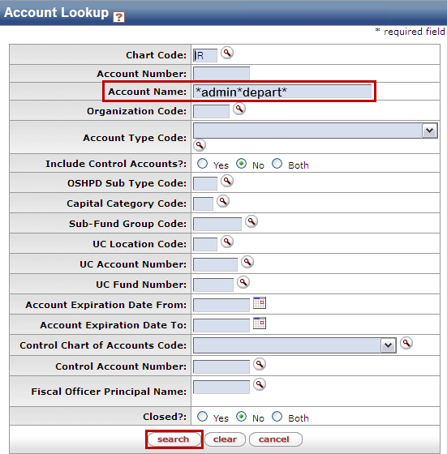  The list below describes the different combinations of text and asterisks to help users find the desired account criteria  Searching for: Return Result General Notes  admin KFS will only return exact match Often= No Results  *admin All results that end with “admin” Limited Results  admin* All results beginning with “admin” Limited Results  *admin* All results with “admin” somewhere in the name Many/ Broad Results  *admin*depart* Anything with “admin” and “depart” in the name, in that order Very refined Results  *admin*&&*depart* Anything with “admin” and “depart” in the name, in any order Ideal refined Results
Alternate | Search for a KFS Account:  Miscellaneous criteria | - You can also search for a KFS Account using other criteria (if the Account Name or UC Account-Fund are unknown) by entering search qualifiers:  - Organization Code - The 4-digit code given to each unit/department/organization in KFS  - Sub-Fund Group Code - The first 2 letters of the KFS Account Number (except for Plant Funds). It categorizes different types of funding for reporting  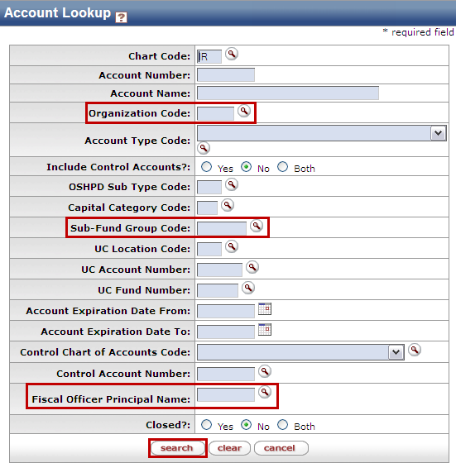  - Fiscal Officer Principal Name - UCInetID of the Fiscal Officer responsible for a KFS Account  - Press the search button, once search criteria has been entered
5 | Review Search Results | - All search results will display under the search button  - If you don’t find the desired search result, the search criteria might need to be edited, e.g. Fix spelling errors or add “*” to search qualifiers or use partial search words)
6 | 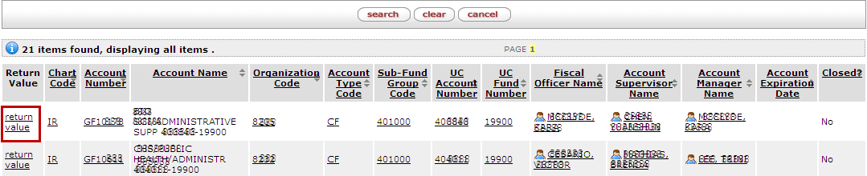  Select the desired KFS Account | - From the list of search results, identify the correct Account and select the return value link on the left.  - Selecting return value will take you back to your eDoc and populate the Account Number field with the selected Account
7 | 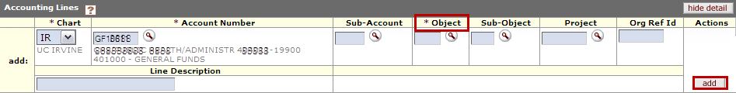  Confirm/Add the Account Number on the eDoc | - The KFS eDoc will show a confirmation of the Account (with brief information) once ‘returned’  - Enter all items in the Accounting Lines section (required items identified by a *), before pressing the add button to add the Accounting Line string to your eDoc

