How to save a document search
Summary: The Name this search field allows you to save a particular search query by a name so you can run the same search at a later time
Steps | What you need to do | How to do it
1 | Name a Search | - To name and save a search, set your search criteria in the various fields, then provide a name in the “Name this search (optional)” field, and then click.  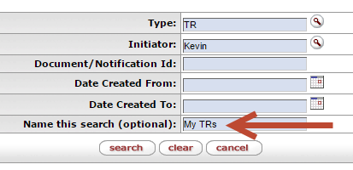
2 | Retrieve a named search | 3. To retrieve a named search, use the dropdown list at the top right of the Document Lookup screen.  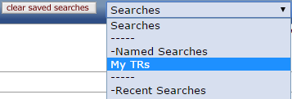
3 | Clear named and recent searches | 4. To clear all Named and Recent Searches, click on the clear saved searches button.

