How to Look Up an Object Code within a KFS eDoc
Summary: Use the Object Code Lookup across multiple document types to find a KFS Object Code. Object codes are necessary on all transactional eDocs where a KFS Account is required.

Notes: Use the object code name field to look up an Object Code within a KFS eDoc. A chart for each ‘searchable’ field in the Object Code Lookup screen assists users with other Object Code Lookup types.

Steps | What you need to do | How to do it
1 | Within the KFS portal, open the Accounting Lines section of an eDoc | - Users must have first initiated and opened a transactional eDoc  - Instructions for filling out various types of eDocs are available on the UC Learning Center website  - Navigate to the Accounting Lines section of the eDoc  - Select the show button, if the tab or section is hidden  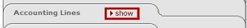 OR
2 | Input or search for an Object Code to fill out the Accounting Lines section/tab  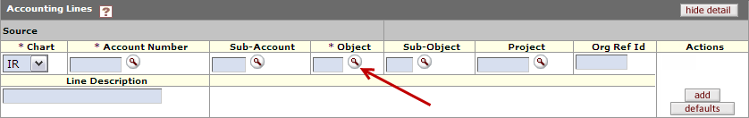 | - The Object field is used for entering the KFS Object Code number  - If you already know the number, enter it in this field and then go directly to Step 7 below  - To perform a search for the Object Code, select the next to Object  - This displays the Object Code Lookup search screen  The screen shot (below) is an example of an Accounting Lines section. Some documents may include additional fields.
3 | Enter the correct Fiscal Year and Campus Code | 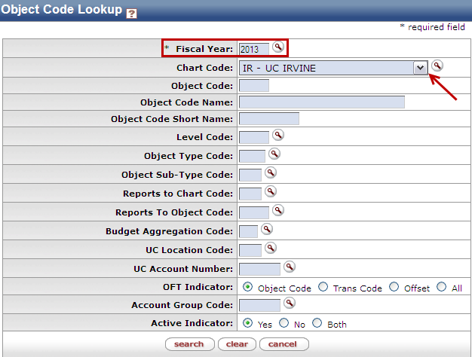  - Ensure that the Fiscal Year and Chart Code is correct  - This will be automatically filled in, but can be changed  Examples:  IR= UC Irvine  MC= Medical Center  SW= System Wide  UC=University of California
4 | Search for an Object Code:  Based on the Object Code Name | - In the Object Code Name field enter a portion of the desired Object Code name. You may use asterisks (*) as search qualifiers  - Almost all object code names are in the plural form, e.g. Supplies vs Supply. Search for partial words or by the plural name spelling  - Press the search button  Note: Asterisks are a way to search in KFS if you don’t know an exact match for something  Note: Selecting the cancel button at any time in this lookup will cancel the search and take you back to the e-Doc  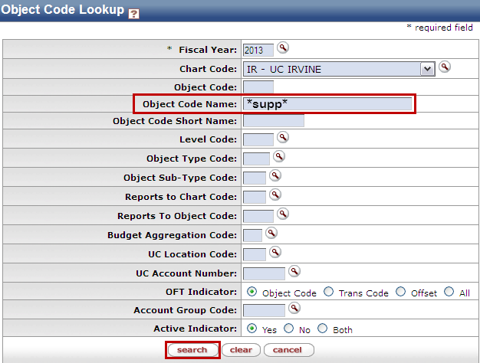  The list below describes the different combinations of text and asterisks to help you find the desired Object Code by name  Searching for: Return Result General Notes  supplies KFS will only return exact match Often= No Results  *supplies All results that end with “supplies” Limited Results  supp* All results beginning with “supp” Limited Results  *supp* All results with “supp” somewhere in the name Many Results  *supp*material* Anything with “supp” and “material” in the name, in that order Very refined Results  *supp*&&*mater* Anything with “supp” and “mater” in the name, in any order Ideal refined Results
Optional | Limit results by entering an Object Type Code | - You can limit and/or refine the Object Code searches by including the Object Type Code as a search qualifier  - Select the next to Object Type Code to look up the possible Object Type Codes and their names  - Alternatively, enter the 2-digit code for the Object Type, for example:  - EX= Expense Expenditure  - IN= Revenue Cash, etc.
5 | Review Search Results | - All search results will display under the search button  - If you don’t find the desired search result, the search criteria might need to be edited, for example:  - Correct the spelling errors  - Add * to search qualifiers  - Use partial search words
6 | Select the desired Object Code | - From the list of search results, identify the current Object Code and select the return value link  - Selecting the Object Code number on this screen opens a new tab/window and displays the attributes of the chosen object code. To go back, exit the tab/window (in order to select ‘return value’ on the previous screen).  - Select return value to go back to your eDoc and fill in the Object field with the selected Object Code
7 | 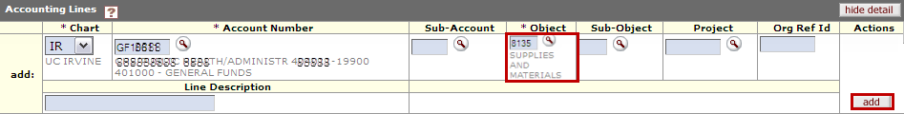  Confirm and add the Object Code number on the eDoc | - The KFS eDoc should show a confirmation of the Object (with brief information) once ‘returned’  - Fill in all other items in the Accounting Lines section (required items identified by a *), before selecting the add button to add the entire Accounting Line string to your eDoc
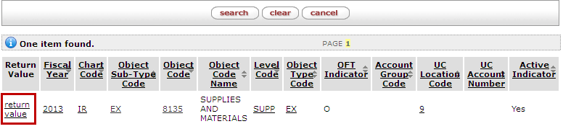

Object Code Lookup: Search Fields

Field | Description | Example
Fiscal Year | This is the valid fiscal year of the object code. The Object Code table is based on fiscal year, so each year can have a different set of object codes. At UC Irvine, it is unlikely that the object codes will change significantly from year to year. | 2013
Chart Code | This code is for the Chart (campus) to which the object code belongs | IR
Object Code | This is a unique (centrally assigned) code within the chart and fiscal year, that describes the nature of the transaction | 8140
Object Code Name | This is a long descriptive name for the object code that appears in the Accounting Lines tab in financial documents, as well as in searches and reports | Supplies Cleaning
Object Code Short Name | This is a shortened version of the Object Code name, for use in reporting where space is limited | Supplies Cle
Reports to Chart Code | This is the Chart Code, in which the object code reports up to. For example, the object code for Cleaning Supplies in the IR-UC Irvine chart might report to the object code Supplies and Materials in the UC-University of CA chart (reported up to UCOP). | UC
Reports to Object Code | This is another Object Code, in which a particular object code may report up to. For example, the object code for Cleaning Supplies in the IR-UC Irvine chart might report to the object code Supplies and Materials in the UC-University of California chart (reported up to UCOP). | 8000
Object Type Code | This is a code used to identify/classify an object code as income, expense, asset, liability, Income, fund balance, etc. Multiple values may exist for income and expense object type codes, to support general ledger functionality. | EX  (Expense Expenditure)
Level Code | This is a summary code for a given set of object codes, which identifies the level to which the object code belongs. This code is useful for reporting, since each object code has an associated level code it rolls up to. Using only a Level Code as search criteria will show all object codes within that level. | SUPP  (Supplies)
Object Sub-Type Code | This is a code assigned to similar groups of object codes. Sub-types are often leveraged in KFS to apply business rules or to help with reporting. For example, UCI uses object sub-types to classify/identify capital asset object codes. | EX  (Misc Expense)
Budget Aggregation Code | This code indicates how an object code can be used for budgeting (and reporting in a hierarchy). Currently, UCI supports budgeting using object code consolidations. | C  (Consolidation)
UC Location | This is the UC Location Code used across all University of California Campus (UC Irvine=9) to identify/differentiate a UC entity | 9
UC Account | This qualifier allows users to search for the (previously used) UC Account Number, which has been converted to an object code. This applies only to Object Codes for Revenue Accounts, Liability Accounts, Balance Sheet Accounts, and Income Accounts (Since these have similar control accounts, but are differentiated by Object Codes in KFS).
OFT Indicator | This marker indicates whether the UCOP attribute of the object code type is an Object Code, a Transaction Code, or an Offset type code. Object Code is the default, with the other indicators mainly being used only by central offices. | O
Account Group Code | This is to identify an Account Group, as part of the UC Office of the President (UCOP) attributes and reporting
Active Code | Select this option if the object code is active and can be used on financial documents (vs. No for code that is no longer valid) | Yes

