Kuali Vendor Onboarding (KVO)
User Manual for UCI Campus

______________________________________________________________________________________
May 22, 2014

Checklist before Inviting a Vendor
To avoid unnecessary phone calls from your potential vendors, you need to assess whether or not the vendor has already been on-boarded before sending out an invitation. Generally, start by searching for your potential vendor using KFS link kfs/portal go to the vendor section and look up vendor.

Step 1 Lookup Vendor in KFS
- Go to Main Menu. You may search for the vendor from the vendor lookup. To search for a vendor, select Vendor from the Main Menu tab.
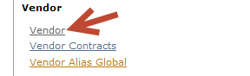
- Enter vendor name with an asterisk * after vendors first name…example Aramark* click enter, if you find the vendor verify details by opening the vendor information to confirm if this is the vendor you are looking for. You can also place asterisks before and after the name *Aramark* the system will return vendors with the name Aramark in any part of the vendor name.
- If the vendor is found, stop here. It is not necessary to send an invitation.

Please note: If vendor is found in KFS, but not in KVO that’s because OIT did a mass upload to KFS directly without inviting vendors - therefore not found in KVO.

Step 2 Search for vendor if not in KFS
If you cannot find the vendor in KFS, it might be that the vendor has registered via KVO but the Vendor Coordinator has not approved the document because she is waiting for TIN match or verifying certain vendor information. Go to the KVO link KVO/VendorList and click the (radio dial) In Vendor OnBoard Form to see vendor details.

- Contact the campus Vendor Coordinator, if it has been over two days after the document was created and showing completed in KVO, but not in KFS.

Step 3 Search Vendor in Kuali Vendor On-Boarding (KVO) Site to invite
- Go to KVO link KVO/VendorList to determine if you should send an invitation. Look up vendor name in both the In Request Form and In Vendor OnBoard Form on the KVO link. If the vendor was already invited once and has not responded, contact your vendor or check email address to verify the address used was correct.
- If you want to delete the request, so you can send a new request just email Vendor Coordinator to delete previous request at KFS@uci.edu .

Page | 2
Step 4 Inviting Vendor for Registration Using KVO
- If the vendor was not invited, then click on Vendor Request to send a request for invitation to the campus Vendor Coordinator.
- You can also track your request by clicking on the Lookup Vendor portion of the link and placing your UCINetID in the Requester UCINetId section which will give you tracking information.
- Once the vendor document is approved, a vendor record is created permanently in KFS.

This is the home page to the KVO site. Please notice the first 3 sections of the KVO site they are:
Home: Vendor Request: and Lookup Vendor:
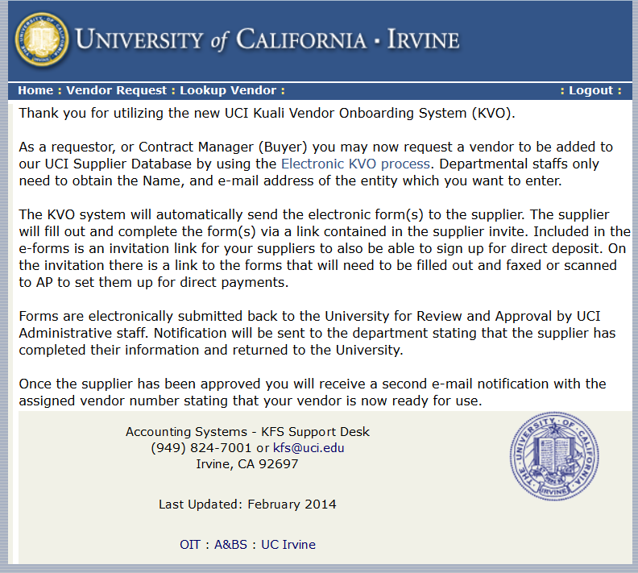
Home: Vendor Request: and Lookup Vendor:
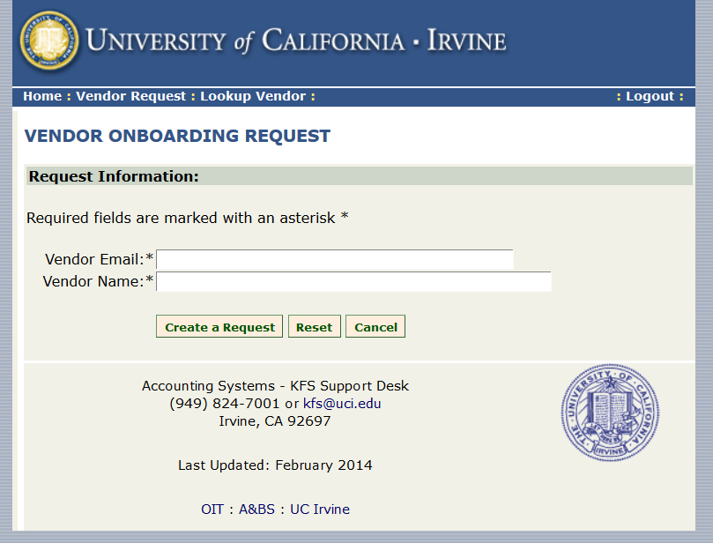
Page | 3

Home: Vendor Request: and Lookup Vendor:
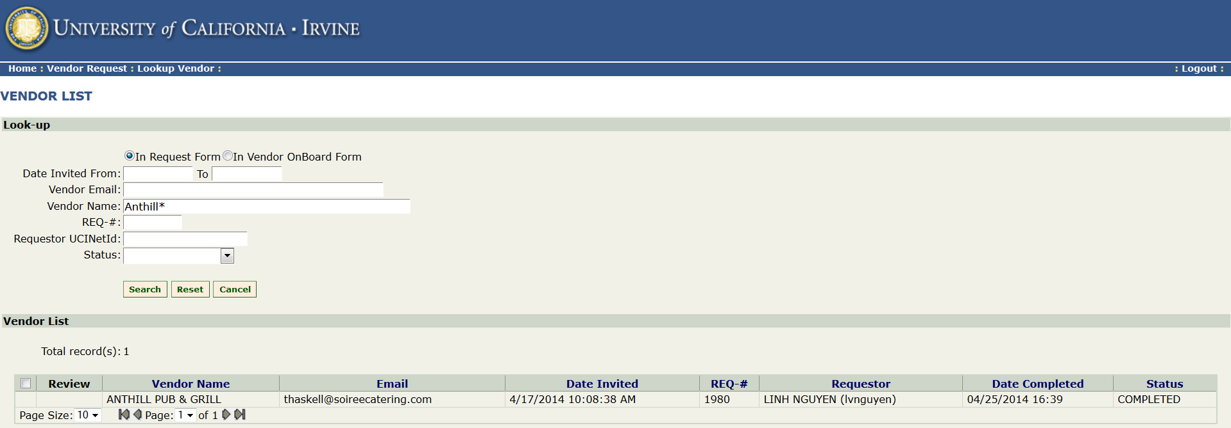
Notice the radio buttons for In Request Form and In Vendor OnBoard Form . These two (2) buttons are utilized to find, if a vendor has been sent a request or if they have completed the process.
If you go to the Status section In Request Form there is a drop down for: Requesting, Invitation Sent, In Progress or Completed. The In Vendor OnBoard Form button will give you more details about the completed vendors.
In Request Form (snapshot above) a completed vendor will have a REQ# use that # In Vendor OnBoard Form section (snapshot below) and it will give you a KVO #, which you can use in KFS to view the vendor (remember vendors might use a different company name to onboard). Notice the vendor Anthill Pub & Grill (above) once they completed the application (below) they used the business name Ranch Hands, Inc.
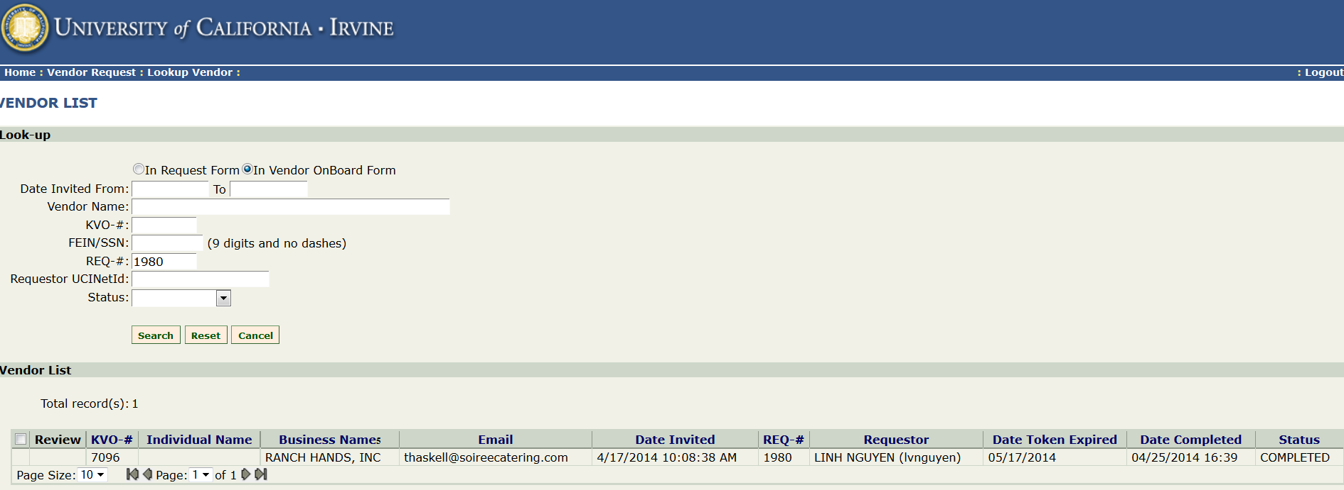

Now take the KVO-7096 #.

Page | 4

Go to KFS site kfs/portal and place the KVO # in the Vendor Name section: KVO-7096 click the search button.
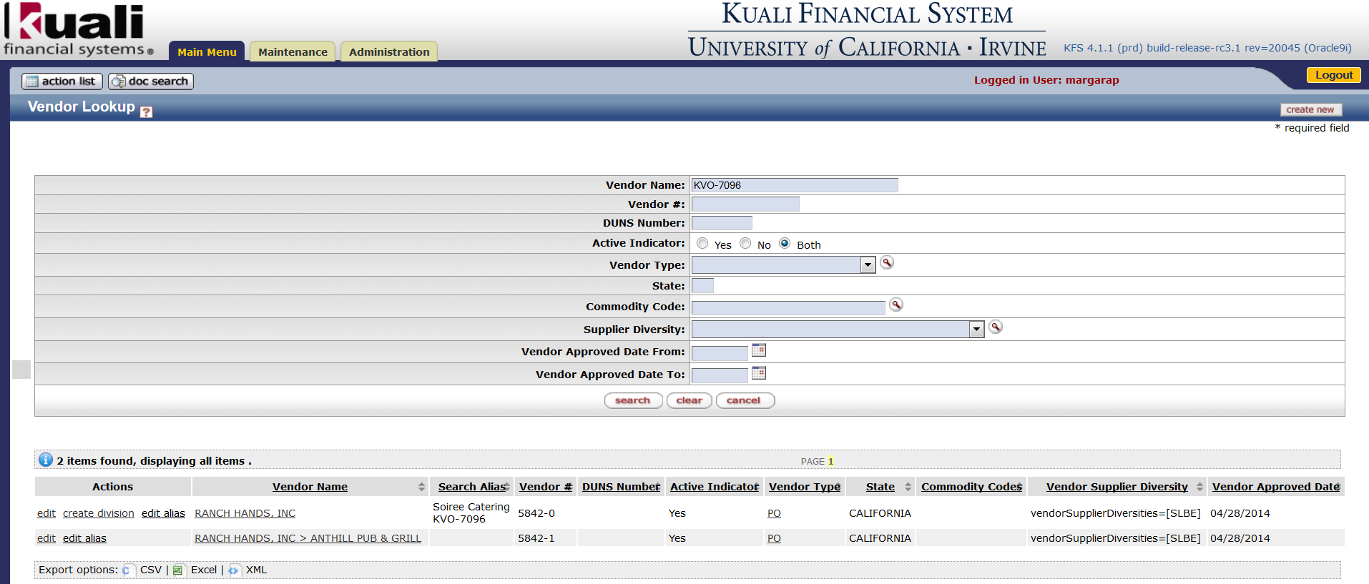
Notice the many Aliases this vendor has as well as the KVO # and Vendor #.

Vendors receive the following #’s:
- REQ # (invitation #)
- KVO # (completed application #)
- KFS # called the Vendor # (vendor Identification #)

Page | 5

