SBS Zotquery Desktop Client Installation Instructions
- Install ODBC Driver 11 for SQL Server
  - Go to link https://www.microsoft.com/en-us/download/details.aspx?id=36434
  - Download and install the required ODBC Driver 11 for SQL Server ENU\x64\msodbcsql.msi
  - When installing ODBC, use default settings.
  - After installation complete, open ODBC Data Source Administrator
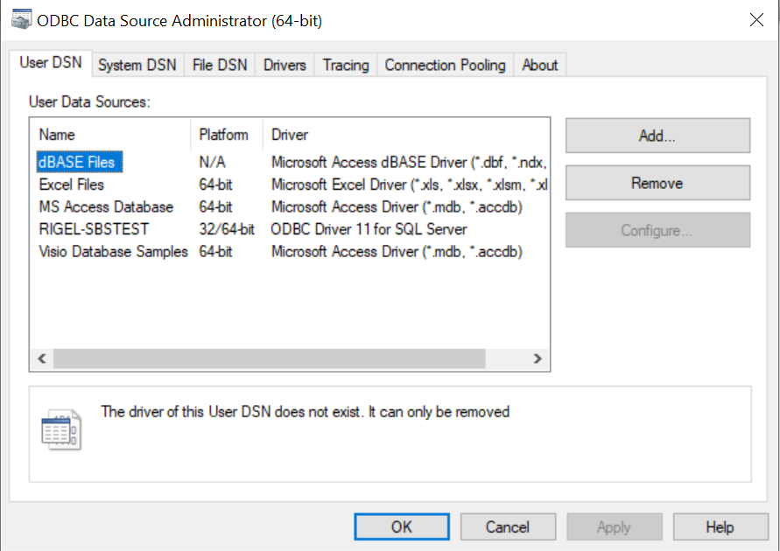
  - Click Add under the “User DSN” section
  - Highlight “ODBC Driver 11 for SQL Server” and click Finish
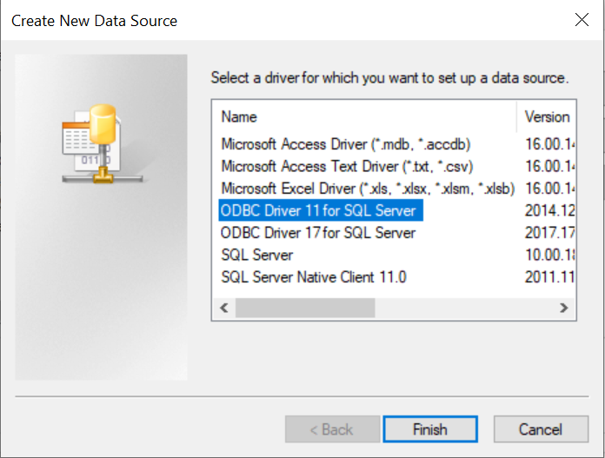
  - Type the following in the “Create a New Data Source to SQL Server” window depending on if you’re installing a production or test instance.
    - Production
      - Name: ORBIT-SBS
      - Description: SBS Production Server
      - Server: 127.0.0.1,1442
    - Test
      - Name: RIGEL-SBSPROD
      - Description: SBS Test Server
      - Server: 127.0.0.1,1439
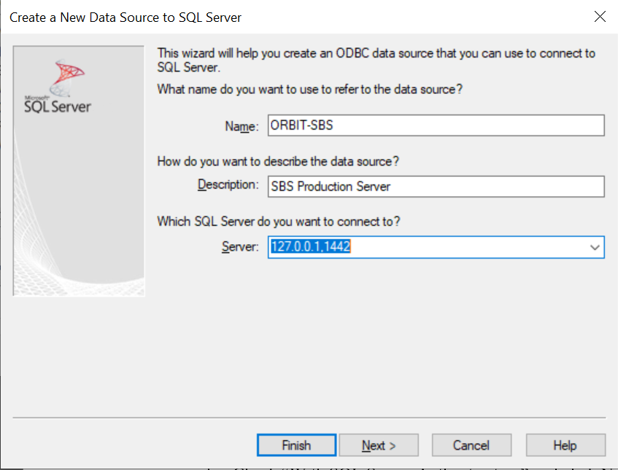
  - Click Next
  - Check “With SQL Server Authentication”, input user login information, and click Next
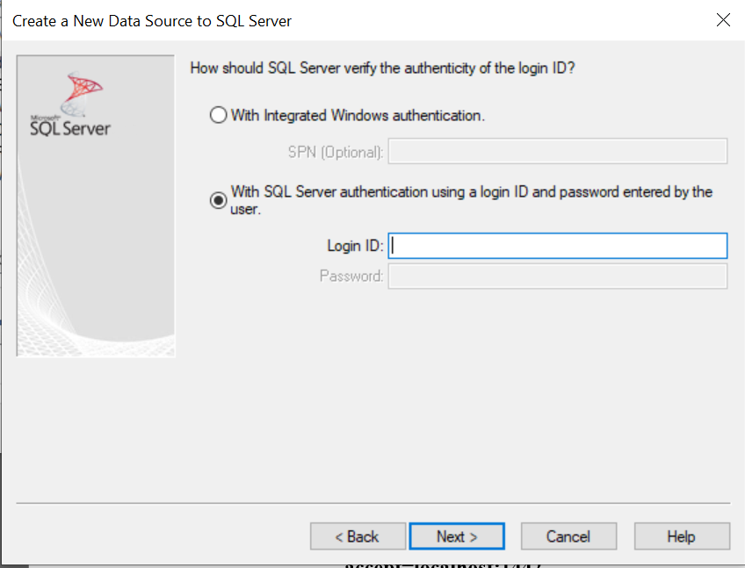

  - Check “Change the default database to:” and use drop down to select “sbs” for production or sbsprod for test.
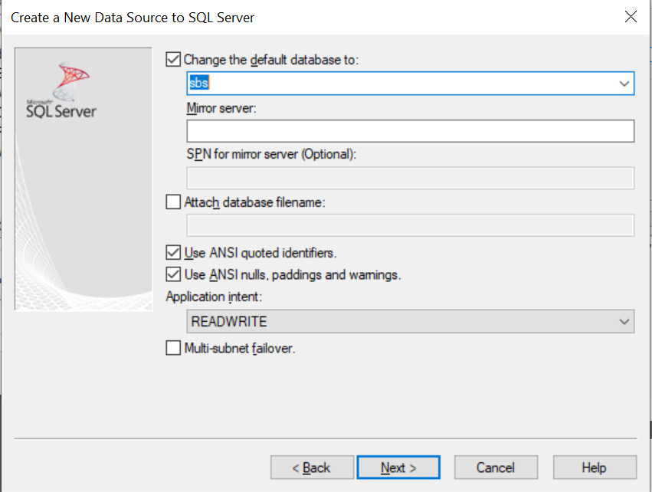
  - Click Next
  - Click Finish
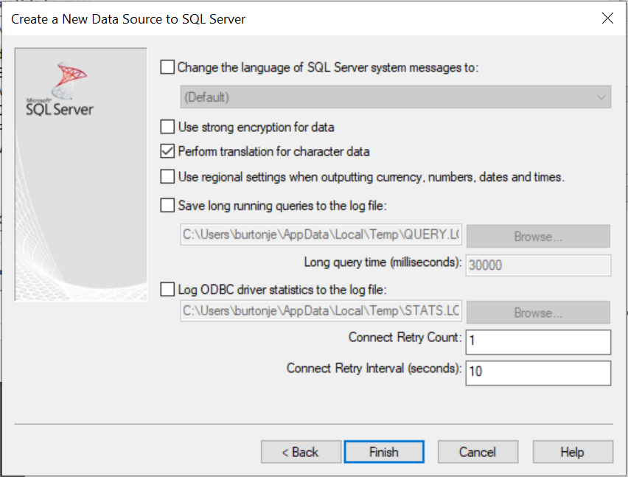

  - Click OK
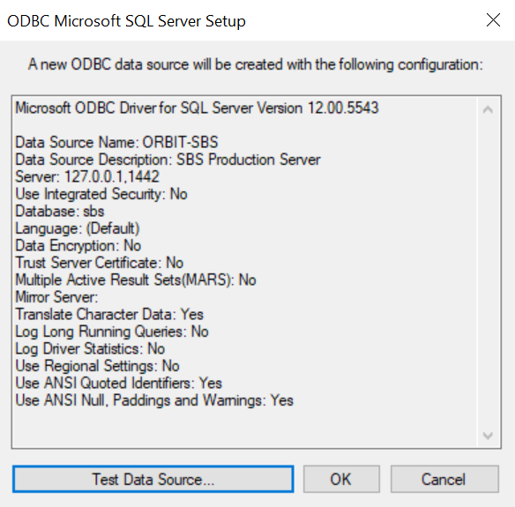
- Stunnel Installation
  - Download Stunnel for your operating system from https://www.stunnel.org/downloads.html
  - Install Stunnel on your computer
  - Use the following configurations within stunnel.conf (file should be located at either C:\Program Files (x86)\stunnel\config\stunnel.conf or C:\Program Files\stunnel\config\stunnel.conf)
    - Production
[Orbit-db]
accept=localhost:1442
connect=orbit-db-p-1.ad.uci.edu:4433
delay = no
    - Test
[Rigel-db]
accept=localhost:1439
connect=rigel-db-d-1.ad.uci.edu:4433
delay = no
  - Reload configuration of stunnel to be able to connect in app

- SBS Zotquery Client Installation
  - Download the SBS Zotquery Desktop Client package sbs.exe
  - Execute sbs.exe and extract the files to c:\Program Files\SBS\.
  - Open the SBSYTEM.INI file and verify the following values match:
Production
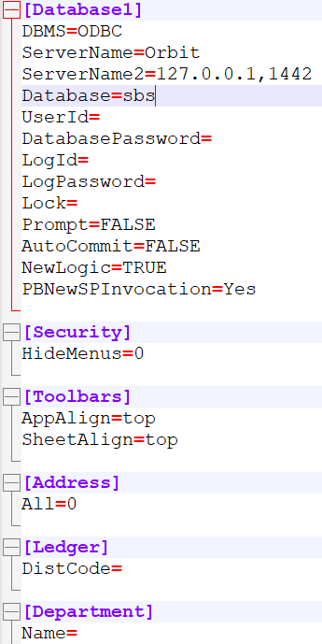

Test
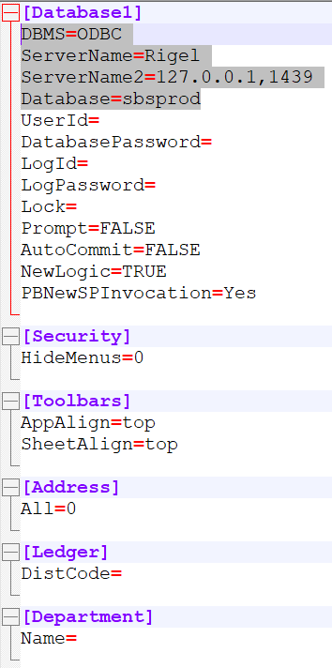
  - Create Desktop Shortcut for SBS Client
  - Open shortcut and verify login for application is successful
Prepared by: Julian Burton
Update Date: April 18, 2023

